Bishop Ullathorne Catholic School

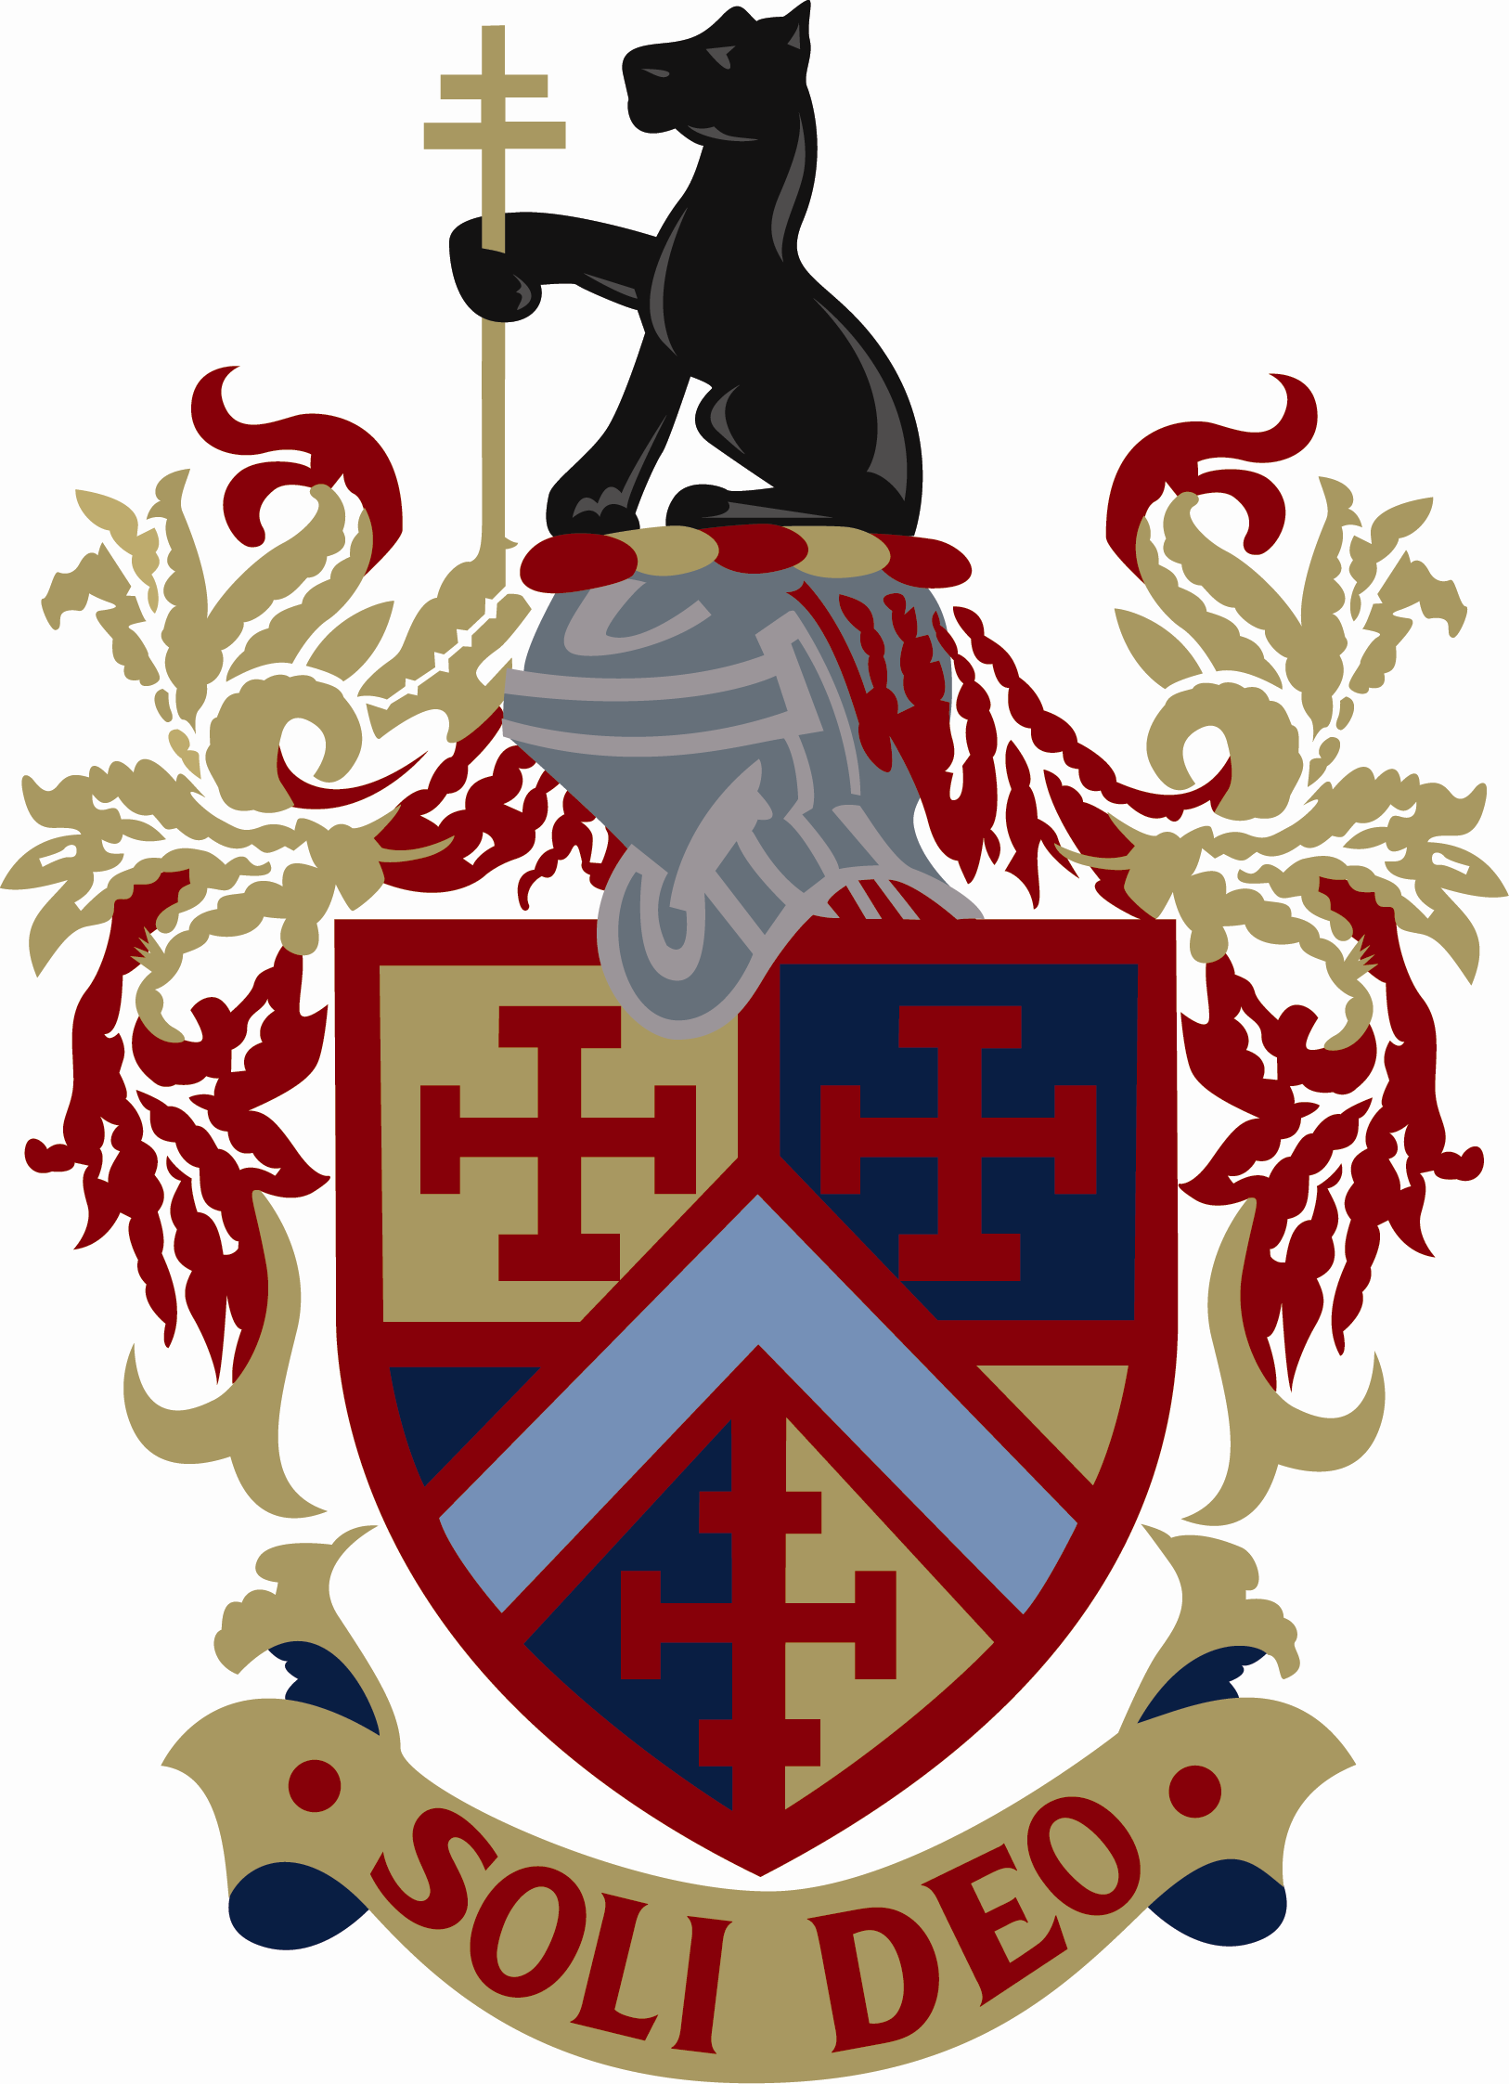

Application form for travel pass
Academic Year 2023/ 2024

Please read carefully and complete ALL sections.
The deadline for receipt of applications is Monday 14 August 2023.

Section A
Child's details:
Surname……………………………………………… First name………………………………………….
DOB………………………
Address………………………………………………………………………… Postcode………………….
Year Group/ tutor …………………………………………………

Section B
Bus number ……….
- I am applying for a bus pass for the above named child on the above route. I understand I am committing to pay the school the total of £330 for the pass for the whole academic year. (Please note you cannot buy a bus pass for individual terms i.e. only pay for the autumn or the spring term).
- I agree to pay the school either the amount of the pass in full (£330) or termly (£110) over three terms (autumn 2023, spring 2024 and summer 2024) or in monthly instalments (£33) over ten months (September 2023 to June 2024).
- If you believe, you qualify for a pass due to low income you can apply for a funded pass through Coventry City Council. Please refer to the following website:
https://www.coventry.gov.uk/schools-schooling/school-travel-passes
- Please note students cannot change bus route without the written permission of the school. This is to prevent overloading on the buses.
- Students will be issued with a plastic travel pass, which they must show the driver when travelling. Copies and images held on phones will not be accepted.
- A charge of £5 will be made for replacing lost cards.
Terms and condition of travel
Students MUST:
- Board the bus sensibly. Stand well back from the kerb as the bus approaches the bus stop. Do not alight until the bus has completely stopped.
- Remain seated where seats are available. Do not stand on the upper deck, staircase or block gangways/ emergency exits.
- Be polite and courteous to the driver and other passengers on board.
Students MUST NOT:
- Litter, throw water bottles etc. around the bus. They should not shout from windows or behave in a way that would cause offence, upset or injury to any other person.
Anti-social behaviour of any kind will not be tolerated and the school/ bus company reserve the right to suspend a student from using the school bus.
Section C
Parent/ carer details:
Mr/ Mrs/ Miss/ Ms……….Surname……………………………………….
First name……………………………………………..
Address (If different from the student’s) …………………………………………………………
………………………………………………………………………………………………………..
Telephone number (Home)…………………………………............ (Mobile)…………………………………………………….
I understand I am committing to purchasing a bus pass for the whole academic year 2023/ 24 and understand the terms and conditions of travel. I will ensure my child is aware of the terms and conditions of travel.
Parent/ carer signature: …....................................................................Date:………………………….

Please complete and return the application form by Monday 14 August 2023 to:
Bus pass applications, Bishop Ullathorne Catholic School,
Leasowes Avenue, Coventry, CV3 6BH
Email admin@bishopullathorne.co.uk

