OBSERVATIONAL DRAWING/PAINTING – CURIOUS PORTRAITS BRIDGING TASKS – SUPPORT SHEET

supported by critical analysis (Practical workshops supported by critical studies).
Emphasis on developing observational drawing skills & judgements; the visual elements; & correct use of art vocabulary.
EVIDENCE
5 experimental study sheets on paper in a sketchbook, computer or Tablet (different media/ techniques – showing related artist links) - detailed annotations & links to selected artist work). Covering Asst Objective:, 1. Develop, 2.Refine ideas. 3. Record. 4. Present Journey with outcomes

PEN – DRAWING- Inspiration 1 – AO1
VINCE LOW
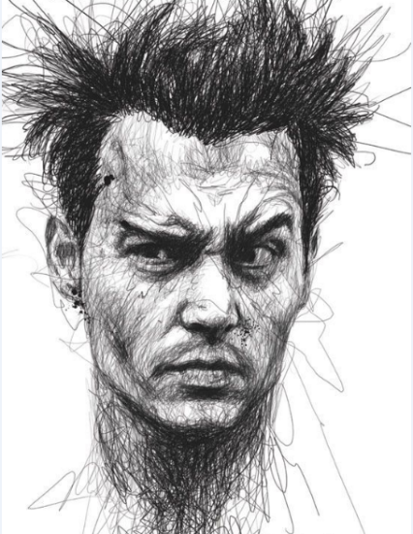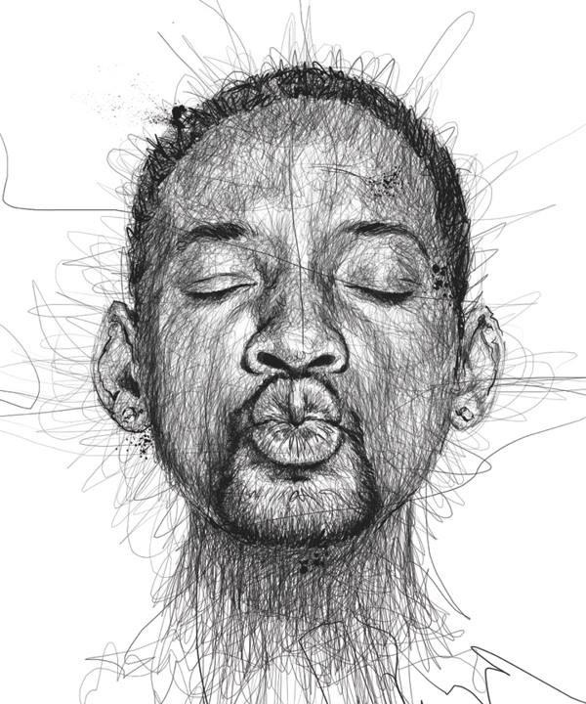

TONAL STUDIES USING LIGHT WATERCOLOUR WASHES – Tablet drawings – Photographs that can manipulated in the artist style and then painted from your creation – Inspiration 2 – 3 – AO1
Andy Butler – Chuck Close
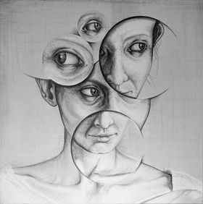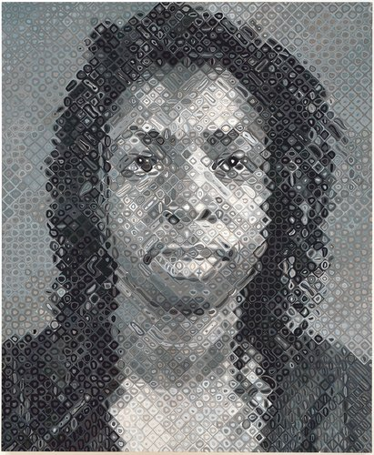
- CREATE a series of Photographs from UNUSUAL ANGLES, DIFFERENT VIEWPOINTS, ANGLED, LIGHTING EFFECTS, CLOSE UP ZOOMED SHOTS – 15 – 20 Decent shots needed AO3
- Present your images in PowerPoint, Word with explanations to show how you captured your Photographs AO3
- From these Photographs create 5 detailed section drawings in a variety of media, choice of media, pencil, pen, collage, Tablet – Pro Create drawings, Photoshop manipulations AO2, 3
- TO create 2 A5 size (half the size of A4) detailed Portrait drawings from your Photographs using the GRID method to ensure drawings are accurate, or from the smartphone pic, drawing the image from an interesting zoomed in section. OR observing images closely to explore emotion and ensure proportion in drawings are as accurate as possible.
- To CREATE an artist style image from the artist inspiration above. USING YOUR OWN Drawings (created in task 4) and Photographs to explore the techniques and skills of the artist. Create YOUR own Portrait versions in a choice of media, pencil, paint, tablet, manipulation through collage or Photoshop in their style. AO1, 2, 3
- CHOOSE a second artist of your choice from Art 2 day website (link below) You will need to focus on drawing and painting predominantly as this will need to be practised thoroughly before we start the course. Create your own Portrait version inspired by the artist style, way, technique or creative approach. AO1, 2, 3
- THE choice of media is Over to You – so Tablet inspired studies, Photograph manipulations that are then used to create your PORTRAIT OUTCOMES are encouraged. AO4 are the potential outcomes and a selection of past A Level students’ work is below:
https://www.art2day.co.uk/
Password – ‘imagine’ ONLY If prompted.
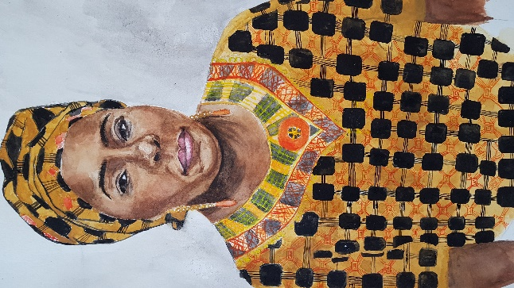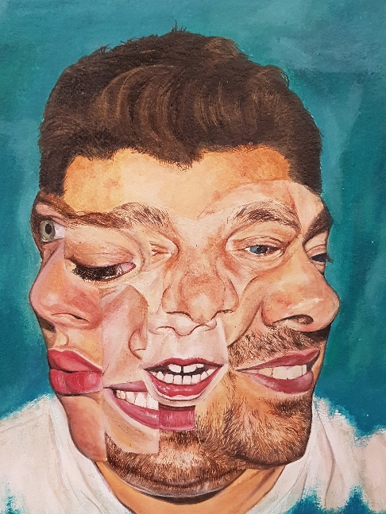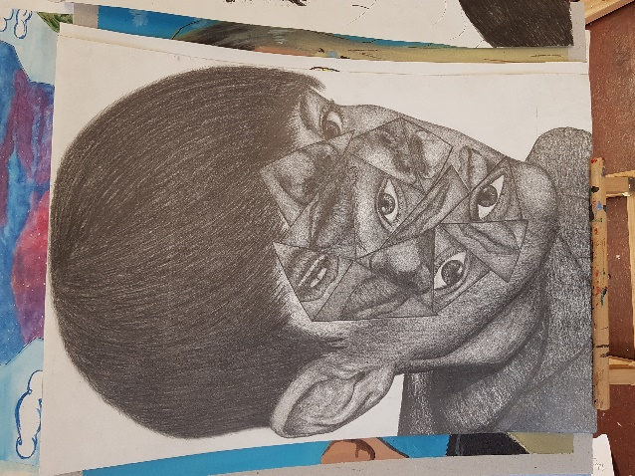
Clare Sanwo – Culture Nikola Werens – Trapped Savannah Goggins – Visage
TRY to engage with the tasks as best you can. How you present the work is down to you, you could photograph the journey and upload it onto PowerPoint. Collate the journey on paper or in a sketchbook. OR a tablet that will document your steps, images and processes used.
Submit work in September during the first lesson of A Level when we get back. This is aimed to support your learning, inform your decision making in preparation for A Level Art. Most important thing to consider is the plans, initial ideas you have that I will form as part of our initial discussion in the first few lessons back.

