Photography – CURIOUS PORTRAITS BRIDGING TASKS – SUPPORT SHEET

supported by critical analysis (Practical workshops supported by critical studies).
Emphasis on developing observational Photography skills & judgements; the visual elements; & correct use of Photography visual language and vocabulary.
EVIDENCE
4 shoots in a PowerPoint Presentation (different media/ techniques – showing related Photographic links) - detailed annotations & links to selected Photographers’ work). Covering Asst Objective: 1. Develop, 2.Refine ideas. 3. Record. 4. Present Journey with outcomes
YOU will have to use Smart Phones as these devices will all have powerful cameras on them, more than suitable for these tatask. Or you may use your own Digital Cameras if you have one.

Colour Photography - Inspiration 1 - 2 AO1
JULIE MOOS – Inspiration 3 Ezekizl – Inspiration 4
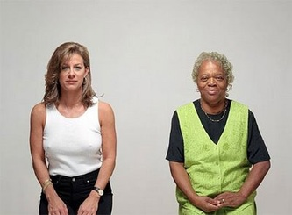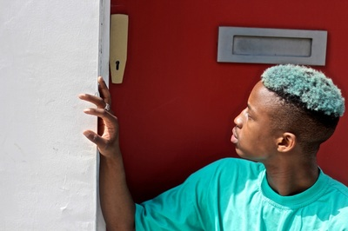

TONAL – BLACK AND WHITE PHOTOGRAPHY - USING LIGHT – Inspiration 3 - 4
Adam Pizurny – Shadows, Light Reflection Nils Orth – Close Up – Framing 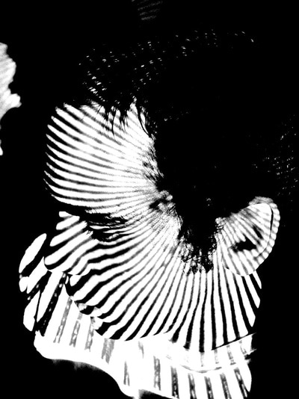 AO1 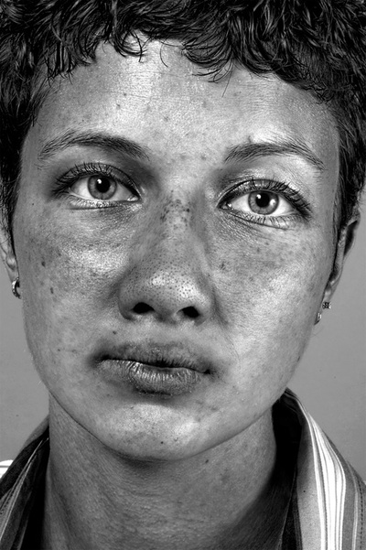

- CREATE a series of Photographs from UNUSUAL ANGLES, DIFFERENT VIEWPOINTS, ANGLED, LIGHTING EFFECTS, CLOSE UP - ZOOMED SHOTS of the face using a camera or smartphone device – 15 – 20 Decent shots per shoot inspired by composition in COLOUR and BLACK AND WHITE above – try to have 4 shoots containing 15 – 20 shots per shoot AO3
- Present your images in PowerPoint, Word with explanations to; How you captured the Photographs, lighting effects used, angles and viewpoints used to capture the effect you created. Analyse the whole shoot not each Photo. You can always refer to Photographs you like by cross referencing the image number AO1, 2, 3
- From these Photographic shoots, present them all on PowerPoint and have 4-5 of the best COLOUR photographs in your opinion from the contact sheet on 1 slide. For BLACK & WHITE 4-5 of the best in terms of framing, mood, lighting, contrast, atmosphere – write a DETAILED account of how it was done and created at the bottom of each set of 4-5 images. Q’s to consider - Why you think these are successful? Have you used an effect? What was it? Where was the picture taken? Was it linked to a specific Photographer from the inspiration above? AO1, 2
- NOW context – choose a Photographer from the inspiration section above. Find out about their work, how they capture images, why? Where and in your opinion, what you find interesting about the work being specific on characteristics. Present this on a couple of slides on the same PowerPoint AO1
- USING art2day link below – in the Photography tab do some research of your own on a Photographer that you find interesting. Produce a detailed analysis sheet on their work over a couple of slides using questions above to assist you AO1
- NOW with the images you have selected or taking a few further images if required, try to capture a similar composition to the Photographers you have picked from the 2 parts of research. AO4 are the potential outcomes and a selection of past A Level students’ work is below:
- PRESENT all the above tasks on a PowerPoint to show the journey of tasks you have been on.
https://www.art2day.co.uk/
Password – ‘imagine’
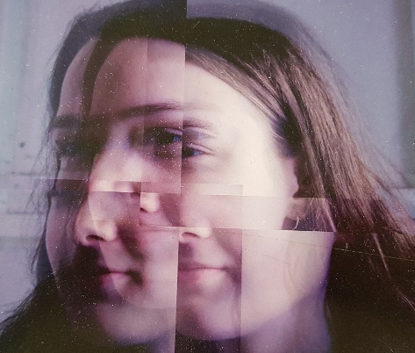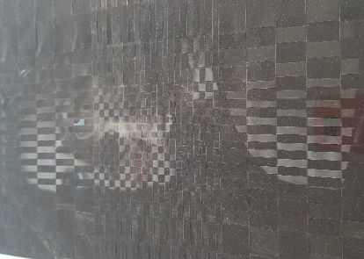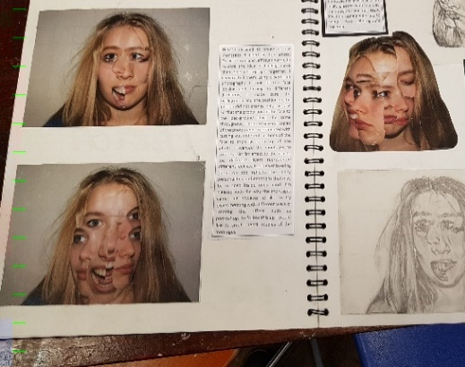
Harrison Ray – Montage Paolo David – Translucent Nikola Werens – Trapped
TRY to engage with the tasks as best you can. How you present the work is down to you, you could photograph the journey and upload it onto PowerPoint. OR ICT software, tablet if you have one that will document your steps, images and processes used.
Submit all work in September during the first lesson of A Level when we get back. This is aimed to support your learning, inform your decision making in preparation for A Level Photography. Enjoy the task and have a go so I have an idea of your skills and techniques ready for further discussion in September, enjoy.

