Graphic Design – BRIDGING TASKS – SUPPORT SHEET

EVIDENCE
PowerPoint Presentation (different media/ techniques – showing related Graphic Design links) - detailed annotations & links to selected Design work). Covering Asst Objective: 1. Develop, 2. Refine ideas. 3. Record. 4. Present Journey with outcomes

History of Typography Bauhaus - Inspiration 1 - 2 AO1
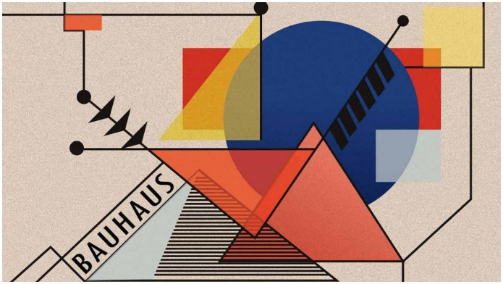
Contemporary Graphic Design – Inspiration 3 - 4
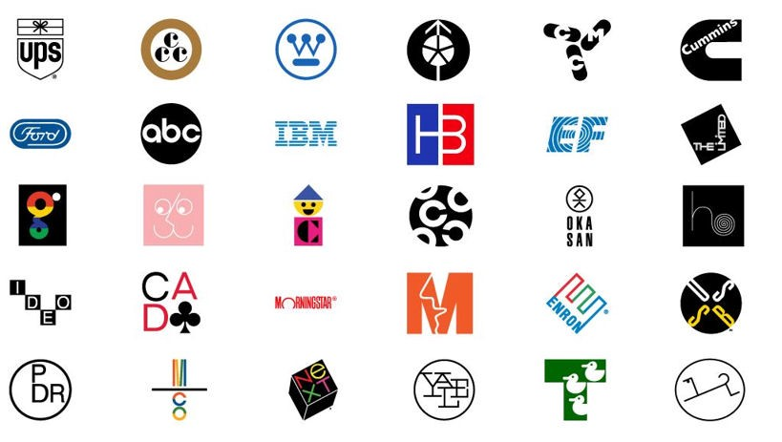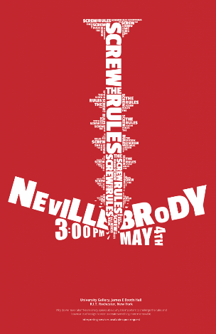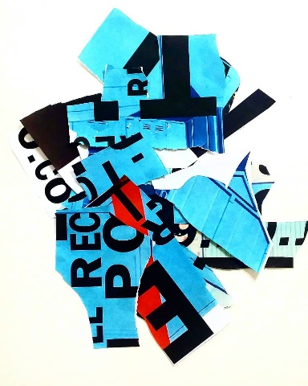
Paul Rand Neville Brody David Carson - AO1

- Research the history of Typography – including the Bauhaus as a pinnacle influence to design. Typographic style and change over the years. San, San Serif types, Baskerville and the importance of Leading, Kerning, spacing in your presentation must be done and in the style of the Bauhaus posters to present your research. Consider colours, shapes, scale and layout of key information. See examples above.
- Research must include your own opinions and references to design aspects you have a particular interest in. AO1, 2, 3
- Produce a context page on David Carson and Neville Brody including key works and opinions about their design work. You could also consider their design style in creating the contextual page in their style through the assistance of the research you produce, see examples above. AO1, 2
- Using the Paul Rand Inspiration (see example logos by Rand above). AO1 Have your own go at designing your own Logo, this can be drawn or digital. Think about what makes a good logo. Then the interaction with letter shapes and form and how they are joined up together to make a successful name brand for a product related to your intention. This could also be a series of modified logos showing the tweaks to each design or a series of different designs to certain brand types.
https://www.art2day.co.uk/
You Tube has some great links to quick how to videos on how to create basic conceptual logos using Photoshop or Illustrator.
I will set up your Adobe account prior to the six week holiday.
Below are past student Graphic Design student examples to spark some interest

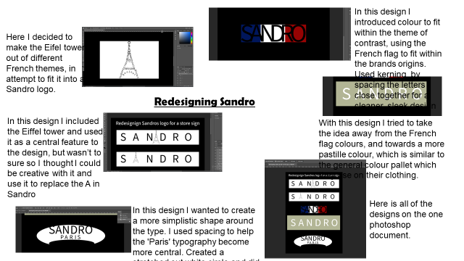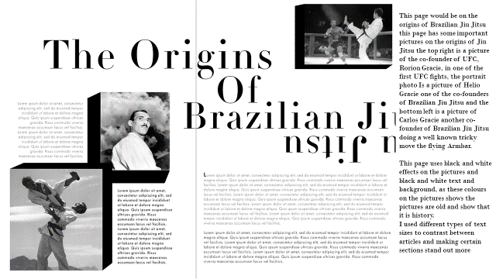
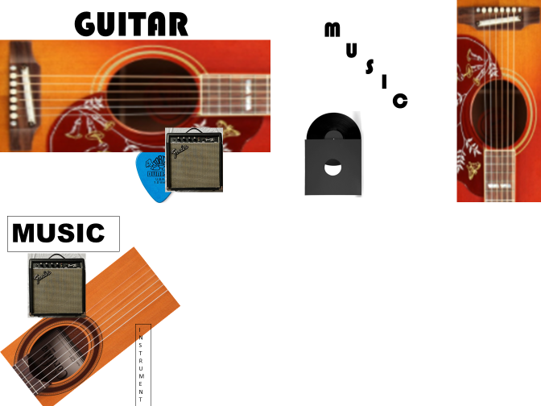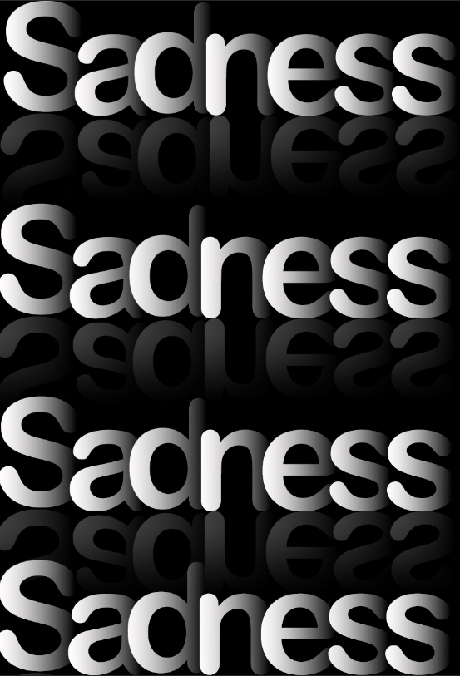
Top Left – John Stewart Jude Fagan
Bottom Left - Ben Dodgson Max Healy
TRY to engage with the tasks as best you can. How you present the work is down to you, you could photograph the journey and upload it onto PowerPoint. OR ICT software, tablet if you have one that will document your steps, images and processes used. PowerPoint is a great application to present your digital work, research and ideas.
The work you create will be presented, submitted in September during the first lesson of A Level when we get back. This is aimed to support your learning, inform your decision making in preparing you for A Level Graphic Design.

