Bridging Task
Select one skill/ technique from ‘Area of Assessment 2’ (AA2) that is a weakness in your sports performance (see below for guidance). The weakness selected can be in your own performance or the performance of another.
Your weakness must:
- Link to either a core or advanced AA2 skill/ technique
- Be from a competitive context
- Be analysed in relation to the desired outcome (this may be a comparison to an elite performer, correct technical model or own/others’ successful performance).
E.g.
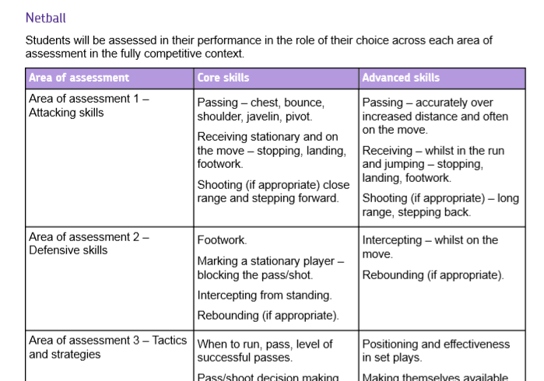

You must analyse your weakness following the criteria checklist below:
Competitive context
Background information/set the scene (e.g. where appropriate- who was performing? Against who? What was happening at the time? What was the score? How had they been performing?)

Analysis of the weakness selected
The technique of the skill is analysed, broken down into the preparation and execution phases:

- Preparation phase:

Which muscles are causing which types of movement?
Which plane/axis is each movement occurring through/ around?
What size is the angle(s) of a type of movement(s)?
Comparison of the above vs elite model (perfect technique)

- Execution phase:

Which muscles are causing which types of movement?
Which plane/axis is each movement occurring through/ around?
What size is the angle(s) of a type of movement(s)?
Comparison of the above vs elite model (perfect technique)

Impact on performance
What is the effect of the technical error(s) upon the overall skill performance? What is the impact of this weakness on the individual and team performance? How does/ could it effect the result of the competitive context/ future competitions?

E.g. A student analysing AA2 in football identifies one technical weakness from the specification: heading for distance and height. They analyse this weakness discussing errors such as lack of knee flexion when preparing to jump, poor connection through using the wrong part of the head and not using arms to gain leverage and taking off from a static position.
With all of these the student directly compares their weakness, comparing all of the errors, to a correct technical model/ elite performer/ when the student performed the header successfully. They explain how each error in the weakness has an impact on their performance in the competitive context. They may find images taken from the competitive context being analysed useful to support this.

Use the example provided as guidance to help you.



