BRIDGING TASK: THE EARLY TUDORS

Purchasing:
If you know that you definitely what to study History in September, you may wish to purchase: (Please note you are not expected to buy these books.)

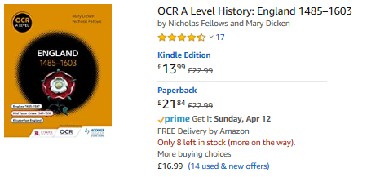

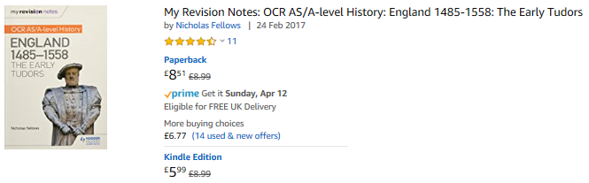

Watch List:

Video podcasts - three revision programs - they give a focused overview of the start of the course about Henry VII- listen and take notes.

https://www.bing.com/videos/search?q=henry+vii&&view=detail&mid=8E036F43677C65ADCA458E036F43677C65ADCA45&&FORM=VDRVRV

https://www.bing.com/videos/search?q=henry+vii&&view=detail&mid=A0E8923BF6E5FA7FB774A0E8923BF6E5FA7FB774&&FORM=VDRVRV

https://www.bing.com/videos/search?q=henry+vii&&view=detail&mid=A8DDB6C057B4F421D810A8DDB6C057B4F421D810&rvsmid=A0E8923BF6E5FA7FB774A0E8923BF6E5FA7FB774&FORM=VDRVRV
Read List

Read and highlight the chapter about Henry VII from Crown and Sceptre by Tracy Borman

Extended writing task:

Based on what you have listened to and read answer the question below

‘Henry VII’s reign was a great success’. How far do you agree?

Your answer should include evidence of his successes as king as well as areas where he was less successful. You should then reach a judgement in relation to the question

EXTRA WATVHING FOR BACKGROUND AND ENJOYMENT

Britain's Bloody Crown - a series that tells the story of the Wars of the Roses - this is the period of history before the Tudors - watch it and create a detailed timeline of events and characters. This will really help you to understand the context of the Tudor period.

https://www.channel5.com/show/britain-s-bloody-crown

