UNIT Y222 THE COLD WAR IN ASIA 1945-1993

INTRODUCTORY TASKS
To help you complete these tasks you should use
- Handout from The Cold War: Teach Yourself pages 2-13
- Any existing knowledge
- Additional independent research

Task 1: What was the Cold War?
Answer this question in your own words. You should aim to produce around 300 words for this task.

Task 2: Different Interests and Different Views
Complete 2 x spider diagrams. One about the USA and one about the USSR (Soviet Union / Russia). In your diagrams identify key points about the interests and views of these two countries clearly demonstrating how they are different.

Task 3: The Yalta and Potsdam Conferences

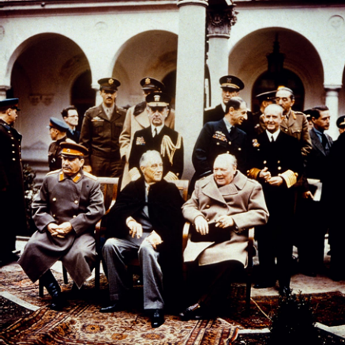
THE YALTA CONFERENCE, FERBRUARY 1945
Highlight the key points on the handout ‘The end of the war in Europe’ about the two conferences. Make yourself some summary notes on the following

- What do you learn from the photo about the Yalta Conference?
- When, where and who was there?
- What were the key areas of tension between the ‘superpowers’?
- What evidence is there of deteriorating relationships between the USA and USSR?
- What points were agreed

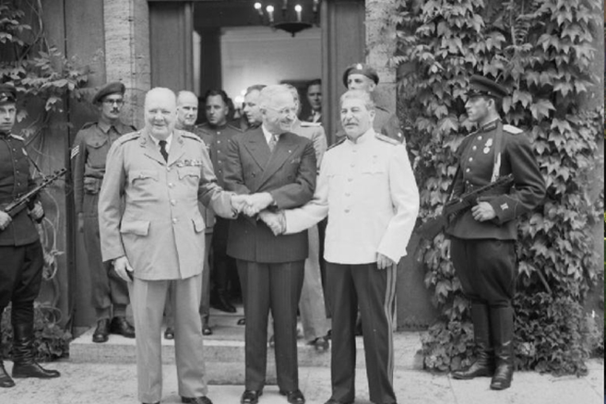

THE POTSDAM CONFERENCE, JULY 1945

- When, where and who was there?
- What was agreed?
- What were the main areas of disagreement?
- What events show the Cold War ‘hotting up?’

Task 4: Features of Communism and Capitalism
Use your knowledge and research to colour code the boxes on the handout to show which are features of COMMUNISM and which are features of CAPITALISM (one colour for each)

PLEASE ENSURE THAT ALL 4 TASKS ARE COMPLETED IN FULL AND BROUGHT TO YOUR FIRST HISTORY LESSON IN SEPTEMBER

IN OUR FIRST LESSON WE WILL BEGIN WITH A SHORT FACTUAL RECALL ACTIVITY TO ASSESSS YOUR UNDERSTANDING ON THE FOLLOWING
- What the Cold war actually was
- The differences between the two ideologies
- The Yalta and Potsdam Conferences

