
A level Biology Bridging task Summer 2026
You may wish to print off this booklet or answer on lined paper
NAME: ………………………………………..
A-level Biology is a big step up from GCSE. To help you succeed on this challenging A level course it is vital that you are organised and have an excellent understanding of the concepts you covered at GCSE and will study in greater depth over the first year of A-level Biology. You will need to complete all tasks outlined in time for enrolment in September.
Year 12 Biology bridging task |  | Ex | Gd | Sf
Task 1:  Organisation | Completed in a suitable format, e.g cornell note taking
Task 1:  Organisation | A file, with dividers
Task 1:  Organisation | and lined paper
Task 1:  Organisation | Stationary
Task 1:  Organisation | Calculator
Task 2: Recapping GCSE knowledge | Complete this bridging task to cover the following key concepts:
Task 2: Recapping GCSE knowledge | Part 1: Maths for Biologists:  Ensure you read through the information, revise if needed and then complete each activity.
Task 2: Recapping GCSE knowledge | Part 2: Practical work for the A level Biologist:  Read through each section and complete all activities related to practical work and data analysis
Task 2: Recapping GCSE knowledge | Part 3: Some key concepts to cover as an introduction to the fundamental principles covered in A level Biology
Task 2: Recapping GCSE knowledge | Apply to different styles of questions.
Task 3: Application skills | Complete the analysis questions set.
Task 3: Application skills | Complete the comprehension questions.
Task 3: Application skills | (optional) Complete an A3 poster on one of the topics suggested
Task 4 – DIRT action | Ensure you FULLY self assess your work to ensure you are A level ready
In order to support completion of this bridging task and transition to A level Biology the books may be of use.


Suitable websites include:
http://www.bbc.co.uk/schools/gcsebitesize/science/add_aqa/ (scroll down to the Biology section)

https://www.physicsandmathstutor.com/biology-revision/gcse-aqa/

https://www.rsb.org.uk/students

Any questions? Email
m.clinton-lees@hccmac.co.uk

Part 1:Maths for Biologists

This section aims to introduce you to (or reinforce) some of the common maths used in Biology.

Activity 1 - Recognise and make use of appropriate units in calculations

Quiz – converting between units
Answers to all of these questions should use standard form e.g. use 5.6 x 10³ rather than 5600, use 4.2 x 10⁻² rather than 0.042.
- How many?
mm in a m |  |  | µm in a mm
µm in a m |  |  | nm in a µm
nm in a mm |  |  | nm in a m
mm in a µm |  |  | m in a µm
µm in a nm |  |  | mm in a nm
µl in a litre |  |  | ml in a litre
µl in a ml |  |  | ms in a s
µs in a ms

- Convert each of the following into metres.
(a) | 70 nm
(b) | 5 µm
(c) | 1 mm
(d) | 0.2 mm

- Convert each of the following into µm.
(a) | 4 m
(b) | 200 nm

- Areas. How many?
(a) | μm² in a m²
(b) | μm² in a mm²

- Volumes. How many?
(a) | mm³ in a cm³
(b) | μm³ in a mm³

- Convert each of these into more sensible units using standard form to express your answers if appropriate.
(a) | 0.0003 μm
(b) | 0.004 km
(c) | 4500000 nm
(d) | 0.0007 s
Quiz – Rates of change
- Express these rates of change with the correct units:
(a) | 2 μg per cm³
(b) | 200 kJ per m² per year
(c) | 10 g per dm³
(d) | 15 cm³ per minute

- In an experiment you were measuring the growth rate of Salmonella. You started with 100 Salmonella and after 2 hours you had 6500 Salmonella. What is the bacterial growth rate?

- In an experiment you were measuring the growth rate of Salmonella. You started with 80 Salmonella and after 4 hours you had 5000 Salmonella. What is the bacterial growth rate?

- How would you express the following in numbers and units?

- A woodlouse crawled 5 cm in 10 min.

- A patient’s drip flowed with 10 drips every 30 s.

- The growth of a slime mould colony was 40 cells per millimetre cubed per hour.

- A breathing rate of 20 breaths in 30 s.

- A change in temperature of 1.2 degrees over three years.

Activity 2 - Recognise and use expressions in decimal and standard form

Quiz – Using standard form

- Convert each of these into standard form, to one decimal place.
1) | 40000000
2) | 8567
3) | 0.0000007
4) | 0.07607
5) | 4500067
6) | 93
7) | 7
8) | 62545

- Multiply these numbers, giving your answer in standard form to one decimal place:

1) | (1 x 10⁴) x ( 6 x 10³)
2) | (3 x 10⁴) x (3 x 10⁻¹)
3) | (2 x 10⁻²) x (3 x 10⁻³)
4) | (4 x 10²) x (5 x 10³)

Activity 3 - Use ratios, fractions and percentages

Quiz – Percentages: Practice calculations

You may be tested on their ability to:
• Calculate percentage yields
• Calculate surface area to volume ratio
• Use scales for measuring
• Represent phenotypic ratios (monohybrid and dihybrid crosses)

- Ventricular systole lasts for 0.3 s. The cardiac cycle lasts for 0.8 s. What percentage of the cardiac cycle is ventricular systole?

- In an onion root tip squash, 200 cells were observed and each cell was assigned to a stage of the cell cycle. Here are the results:
Stage | Number of cells
Interphase | 150
Prophase | 20
Metaphase | 12
Anaphase | 4
Telophase | 8
Cytokinesis | 6

What percentage of cells were at each stage of the cell cycle?

- A soil sample weighed 2.4 g. After heating at 100 ⁰C in an oven to evaporate the water, it weighed 1.8 g. What percentage of the soil sample was water?

- Stearic acid has the formula C₁₇H₃₅COOH. What percentage of the atoms in stearic
acid are:
(a) | carbon?
(b) | hydrogen?
(c) | oxygen?

Quiz – Percentage yield: Practice calculations
- In the following examples you are given the actual yield and the theoretical yield. Calculate the percentage yield.
(a) | Actual yield = 40 g | Theoretical yield = 60 g
(b) | Actual yield = 60 g | Theoretical yield = 100 g
(c) | Actual yield = 90 g | Theoretical yield = 130 g
(d) | Actual yield = 23 g | Theoretical yield = 60 g

- In the hydrolysis of a sample of triglycerides, the theoretical yield of fatty acids is 9.0 g. The actual yield was 7.2 g. What was the percentage yield for this synthesis?

Quiz – Ratio: Practice calculations
- Calculate the surface area-to-volume ratios of the following cuboids:
(a) | A cuboid with sides: 2 cm x 2 cm x 2 cm
(b) | A cuboid with sides: 1 m x 2 m x 4 m
(c) | A cuboid with sides: 1 mm x 1 mm x 8 mm

Quiz – Phenotypic ratio: practice calculations
- Plants were grown either in the light or the dark and the length of the stem was measured.
Growing conditions | Stem length (cm)
Light | 10
Dark | 25

- What was the ratio of stem length, light to dark?

- What was the ratio of stem length, dark to light?

- The stem length experiment was repeated by growing plants under four different coloured lights:
Light used for growth | Stem length (cm)
Blue | 25
Green | 3
Yellow | 10
Red | 15

What was the ratio of stem length blue to green to yellow to red?

- Let’s say colour of naked mole rats is determined by a single gene and brown colour (B) is dominant to white colour (b). If two heterozygous (Bb) naked mole rats were mated, what is the expected ratio of brown naked mole rats to white naked mole rats?

Activity 4 - Estimate results

Quiz – Estimating results
1. Estimate these and check your approximations using a calculator
a) | 15.6 x 24.4
b) | 8.8 x 32.3
c) | 15.6/24.4
d) | 8.8/32.3

2. Here’s an example from ecological sampling. A 0.5 m x 0.5 m quadrat was used to count plants. Ten samples were taken and the plants in each quadrat counted.

The values were: 7, 3, 6, 12, 4, 8, 8, 9, 10, 2

Make an estimate of the density of plants per m².
Now calculate the density of plants per m².

Activity 5 - Use calculators to find and use power, exponential and logarithm functions

Quiz on using calculators

- Use your calculator to determine the value of:
- 12³

- 10⁵

- Log (4)

- Ln(7)

- A bacterial cell divides (doubles) every 45 minutes under standard conditions. There is initially one bacterium in the culture. How many cells will there be after 6 hours?

A bacterial cell divides (doubles) every 35 minutes under standard conditions. There is initially one bacterium in the culture. How many cells will there be after 8 hours?

Part 2 - Practical work for the A level Biologist

Complete the table below:
Key word | Definition
Accuracy
Precision
Repeatability
Reproducibility
Anomalous result
Independent variable
Dependent variable
Control variable
Range
Interval
Validity
Reliability
Resolution
Uncertainty
Zero error
Systematic error
Random error

Using your definitions, read through the investigation and complete the practical skills questions:
Enzyme Activity and Temperature
Experiment:
Investigate the effect of temperature on the activity of amylase by measuring how long it takes to break down starch at different temperatures (e.g. 20°C, 30°C, 40°C, 50°C).
Practical Skills Questions:
- What is the independent variable in this experiment?

- What is the dependent variable?

- Name two control variables.

- Why should you repeat the experiment at each temperature?

- What does it mean if one of your results is an anomalous result?

- How could you improve the accuracy of your temperature measurements?

- How would you ensure your results are reliable?
Osmosis in Potato Cells
Experiment:
Investigate how different concentrations of sugar solution affect the mass of potato cylinders over 24 hours.
Practical Skills Questions:
- What is the range of sugar concentrations you could use?

- Why is it important to keep the size of the potato cylinders the same?

- What is meant by calibration of a balance (scale)?

- How would you calculate the mean change in mass?

- If your measurements vary a lot when you repeat the experiment, what type of error might this suggest?

- What is the resolution of the balance you're using?

- How would you write a conclusion based on your results?

Photosynthesis and Light Intensity
Experiment:
Measure the rate of photosynthesis in pondweed (e.g. Elodea) by counting bubbles produced at different distances from a lamp.

Practical Skills Questions:

- What is the independent variable in this experiment?

- How would you improve the reliability of your results?

- If the lamp was giving inconsistent light intensity, what type of error might this cause — systematic or random?

- What should be included in your risk assessment for this practical?

- Why do you take the mean of your repeated measurements?

- How would you identify and handle an anomalous result in your data?

- What does it mean for your method to be valid?

Part 3: Some key concepts for A level Biology

Cells:
Complete the following table:

Structure | Function
Cell surface membrane
Chloroplast
Vacuole
Mitochondria
Nucleus
Cellulose cell wall
Chromosomes
Ribosomes

Biological drawings
Produce a biological drawing of the cells below. Identify each cell and include all key labels and ensuring that your biological drawing meets the criteria outlined in GCSE biology.
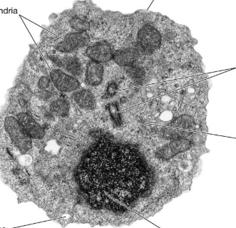
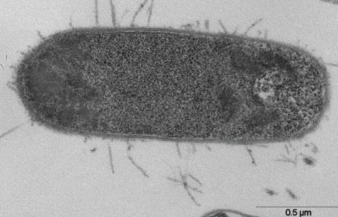
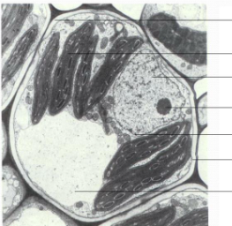

Photosynthesis and respiration
These are two of the most important reactions that takes place in living organisms. They both involve the transfer of energy. In the boxes below. Summarise the key ideas about both processes:
Photosynthesis | Respiration

Plants absorb light energy for photosynthesis. Some colours of light result in a higher rate of photosynthesis than other colours of light. Devise an investigation to discover which colour of light results in a higher rate of photosynthesis. Include experimental details in your answer and write in full sentences. (6 marks)


Principles of moving across boundaries
In the space below, design a venn diagram to show similarities and differences between diffusion, osmosis and active transport:

Practical question:
A student uses this method to investigate osmosis in potato tissue.
• cut three 5.0cm long cylinders from a raw potato
• dry the cut surfaces using filter paper
• measure the mass of each cylinder using a balance
• place one cylinder in a test tube containing 10cm³ of concentrated sucrose solution, one cylinder in a test tube containing 10cm3 of distilled water and one cylinder in an empty test tube
• put a bung in each test tube and leave them for one hour
• remove the cylinders and dry them with filter paper
• measure the mass of each cylinder again
• measure their lengths using a ruler
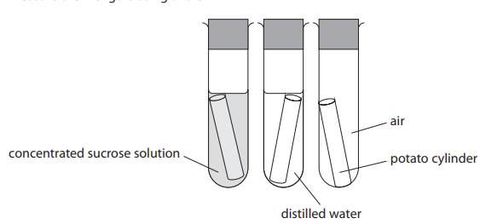

Define what is meant by osmosis (2)


(ii) State the independent variable in the student’s investigation. (1)
(b) Osmosis is affected by the surface area and volume of the cylinders, so the student keeps the original surface area and volume of each cylinder the same. At the start of the experiment each cylinder had a radius of 0.25cm and a length of 5.0cm.
(i) Calculate the surface area of each cylinder using this formula.

surface area = 2πrl +2πr²
[l = length of cylinder, r = radius of cylinder and π = 3.14] (2)

surface area = .............................................................. cm²

(ii) Explain how surface area would affect the rate of osmosis. (2)

State another variable the student should control in the investigation. (1)
(c) The table shows the student’s results for the mass of the cylinders.

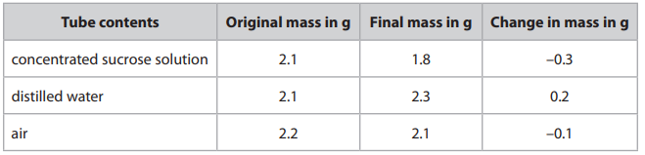

(i) Explain the changes in the mass of the potato cylinder in each test tube. (3)

(ii) The student also measured the change in length of each potato cylinder. Assuming the length has the same percentage change as the mass, calculate the final length of the cylinder in the concentrated sucrose solution. (3)

length = .............................................................. cm

Genetic inheritance

Many characteristics of pea plants are genetically controlled. One of these characteristics is flower position. Flower position can either be axial or terminal.
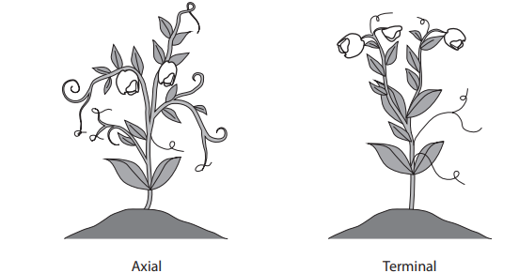
In a first cross, scientists crossed pea plants with axial flowers with pea plants with terminal flowers. This first cross produced 1120 offspring plants. All of these offspring plants had axial flowers.

(a) Use a genetic diagram to show the genotypes of the parent plants, the gametes they produce and the genotypes of the offspring plants. (3)

(b) The scientists allowed the offspring from the first cross to self-fertilise. This second cross produced 858 second generation plants. 608 of the plants had axial flowers and the other plants had terminal flowers.
(i) Calculate the ratio of plants with axial flowers to plants with terminal flowers. Give your answer in the form n:1 (2)

ratio = ............................... :1
(ii) Explain why the ratio of plants with axial flowers to plants with terminal flowers is different from the expected ratio. (3)

(c) Scientists want to discover if plants with axial flowers produce more seeds than plants with terminal flowers. Design an investigation to discover whether plants with axial flowers produce more seeds than plants with terminal flowers. Include experimental details in your answer and write in full sentences. (6)

Task 3: Application skills in Biology:

Complete the analysis questions below:
1) Female sterilisation is another operation that can be used as a permanent way of preventing pregnancy. This involves cutting and sealing the fallopian tubes (oviducts). Scientists compared female and male sterilisation, looking at the outcomes of the operations. This is their data.
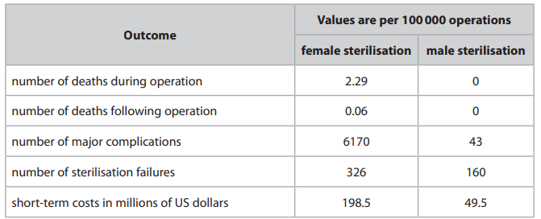
The scientists concluded that male sterilisation should be recommended for most couples considering a permanent way of preventing pregnancy. Discuss this conclusion using data from the table. (4 marks)


2) Patients with reduced numbers of red blood cells are described as anaemic. In an investigation, scientists measure the percentage oxygen saturation of the blood and the rate of tissue deoxygenation. The rate of tissue deoxygenation is a measure of how fast oxygen is lost from the tissues.

They use four groups of patients.
• non-anaemic patients with normal blood flow
• anaemic patients with normal blood flow
• non-anaemic patients with slow blood flow
• anaemic patients with slow blood flow

The table shows the scientists’ results.
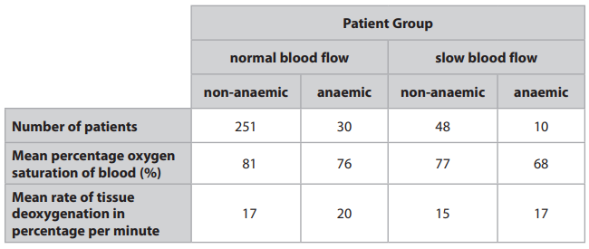
Discuss the relationships between anaemia, blood flow, percentage oxygen saturation of blood and rate of tissue deoxygenation. You should refer to data in the table and use your biological knowledge in your answer (5 marks)

3) The peppered moth is found in many countries. Two different forms of the peppered moth are a light-coloured moth and a dark-coloured moth. The dark-coloured moth was first observed in cities when pollution, from burning coal, stained tree trunks black

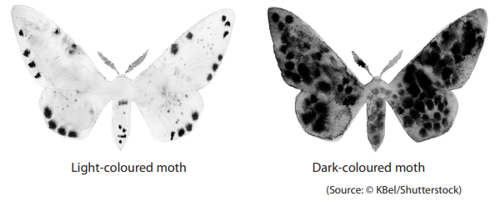
Scientists trapped moths in a city location from 1992 to 1998. The table shows the scientists’ results
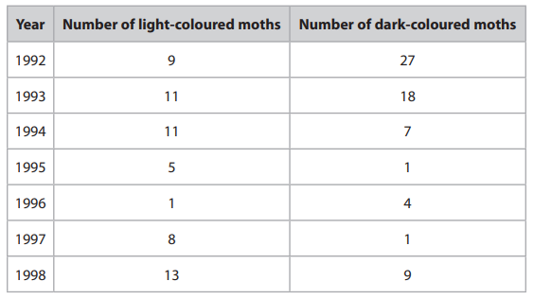
(a) Calculate the difference between the percentage of moths that are dark-coloured in 1992 and the percentage of moths that are dark-coloured in 1998. (3)

difference = ..............................................................%

(b) (i) Plot a line graph to show the number of light-coloured moths and the number of dark-coloured moths from 1992 to 1998. Use a ruler to join the points with straight lines. (5)


(ii) In the 1990s, many cities introduced laws that prevented the burning of coal. Comment on the changes in the number of light-coloured moths and the number of dark-coloured moths between 1992 and 1998. (5)


Comprehension based question:

Read the passage below. Use the information in the passage and your own knowledge to answer the questions that follow.

Plants to the rescue

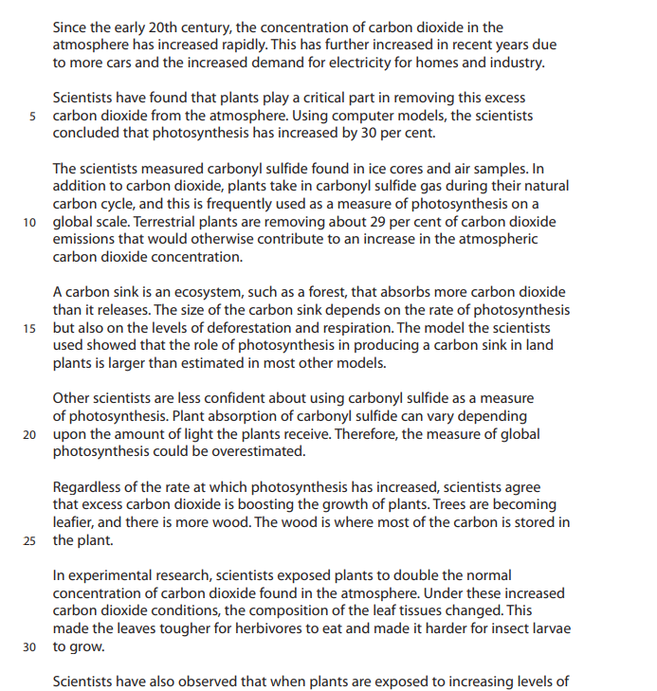
Scientists have also observed that when plants are exposed to increasing levels of carbon dioxide, the size of the stomatal pores on a leaf increases.

(a) Explain why more cars would result in an increase in atmospheric carbon dioxide. (Lines 1-3) (2)


(b) Explain how increased carbon dioxide can cause climate change. (2)

(c) Explain why increasing carbon dioxide concentration can increase photosynthesis in plants. (2)
(d) Explain why the carbon sink depends upon respiration and deforestation as well as photosynthesis. (Lines 13 to 15) (2)
(e) Light affects gas exchange in leaves. (Lines 19 and 20) Describe an experiment that shows how the net gas exchange from a leaf varies with light intensity. (3)

(f) The photograph shows stomata on a small square of the lower surface of a leaf. 400μm (0.4mm)
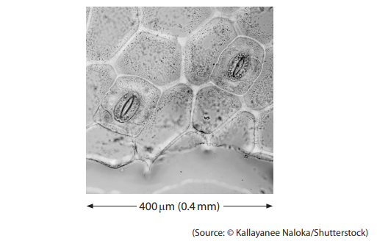
The total area of the lower surface of the leaf is 150cm² . Using the photograph and the total lower surface area of the leaf, estimate the number of stomata on the lower surface of the leaf. (3)

number of stomata = ............................................................

(g) Stomata also have a role in water transport in the plant. Explain the role of stomata in water transport. (2)

2) Read the passage below. Use the information in the passage and your own knowledge to answer the questions that follow.

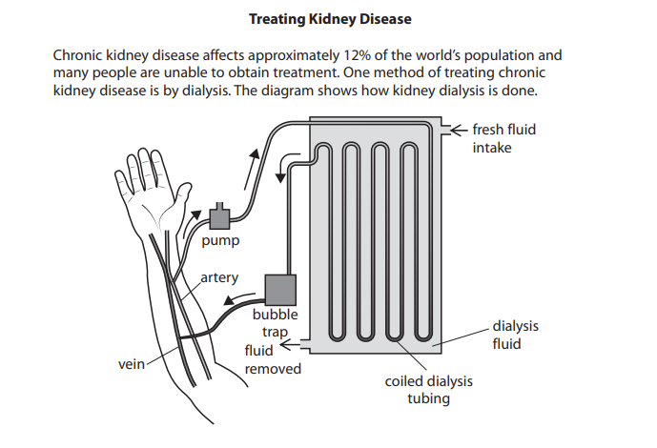
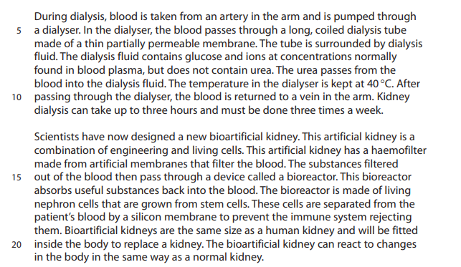

(a) In 2021, the world’s population was 7900000000. Calculate the number of people in the world who have chronic kidney disease (Lines 1 and 2). Give your answer in standard form. (2)

number of people = ..............................................................
(b) Urea is an excretory product that is released by the kidneys. Give the name of an excretory product that is released by the lungs. (1) .....................................................................................................................................................................................................................................................................................

(c) Explain two ways that the dialyser is designed to increase the rate of removal of urea from the blood (Lines 5 to 11). (4)

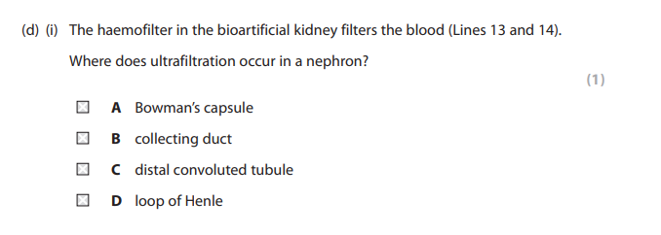
(ii) The cells in the bioreactor absorb glucose from the filtrate in a way that is similar to the cells in a nephron (Lines 14 to 17). Describe how the nephron absorbs glucose back into the blood from the filtrate. (2)

(iii) The bioartificial kidney is connected to blood vessels and to the tube that transports urine to the bladder in the same way as the human kidney. Which row of the table is correct? (1)
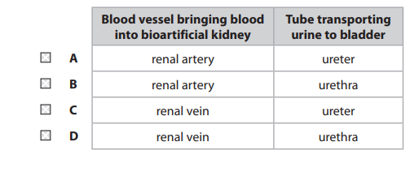
(e) Explain how the pituitary gland and the nephron cells in the bioreactor will respond in a patient who is dehydrated (Lines 20 and 21). (3)


Optional
In preparation for your first lesson in September, you need to complete an A3 poster on one of the following topics:
• The importance of saprobionts
• Outline evidence for The Endosymbiotic Theory
• Our impact on ocean life
• How modern farming methods can support biodiversity
• What can a household do to help limit their impact on the environment

