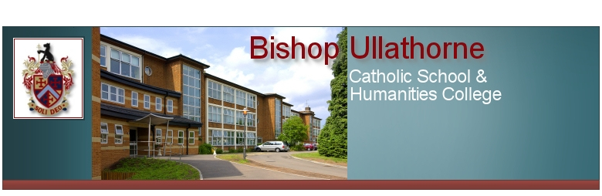
A level Chemistry Bridging
task Summer 2026
You may wish to print off this booklet or, complete on lined paper
NAME: ………………………………………..

A-level Chemistry is a big step up from GCSE. To help you succeed on this challenging A level course it is vital that you are organised and have an excellent understanding of the concepts you covered at GCSE and will study in greater depth over the first year of A-level Chemistry. You will need to complete all tasks outlined in time for enrolment in September.

Year 12 Chemistry bridging task |  | Ex | Gd | Sf
Task 1:  Organisation | Completed in a suitable format, e.g cornell note taking
Task 1:  Organisation | A file, with dividers
Task 1:  Organisation | lined paper
Task 1:  Organisation | Stationary
Task 1:  Organisation | Calculator
Task 2: Recapping GCSE knowledge and skills | Complete this bridging task to cover the following key concepts:
Task 2: Recapping GCSE knowledge and skills | Part 1: Formula literacy
Task 2: Recapping GCSE knowledge and skills | Part 2: balancing equations
Task 2: Recapping GCSE knowledge and skills | Part 3: Measuring amount of substance
Task 2: Recapping GCSE knowledge and skills | Part 4: Bridging the gap between GCSE and organic chemistry.
Task 2: Recapping GCSE knowledge and skills | Part 5: Practical work for the A level chemist: Read through each section and complete all activities related to practical work
Task 3: Application skills | Part 1 – Analysis questions
Task 3: Application skills | Part 2 – Extended response questions
Task 3: Application skills | Part 3 – (optional) Complete an A3 poster on one of the Chemistry topics suggested
Task 4: DIRT action | Ensure you self assess your bridging task to ensure you are A level ready.

In order to support completion of this bridging task and transition to A level Chemistry the following books may be of use.
Suitable websites include:
http://www.bbc.co.uk/schools/gcsebitesize/science/add_aqa/ (scroll down to the Chemistry section)
http://www.docbrown.info/page20/AQAscience2C.htm (scroll down and cover unit 2 and for those of you not having taken separate science, look over unit 3)
http://www.knockhardy.org.uk/gcse.htm - this is the contents page.
Any questions?
email marie.clinton-lees@hccmac.co.uk

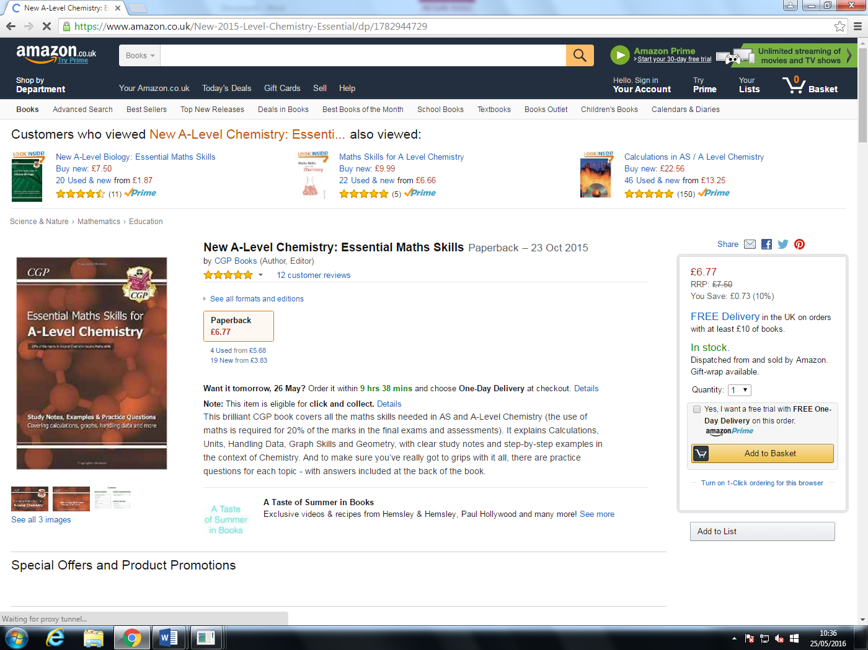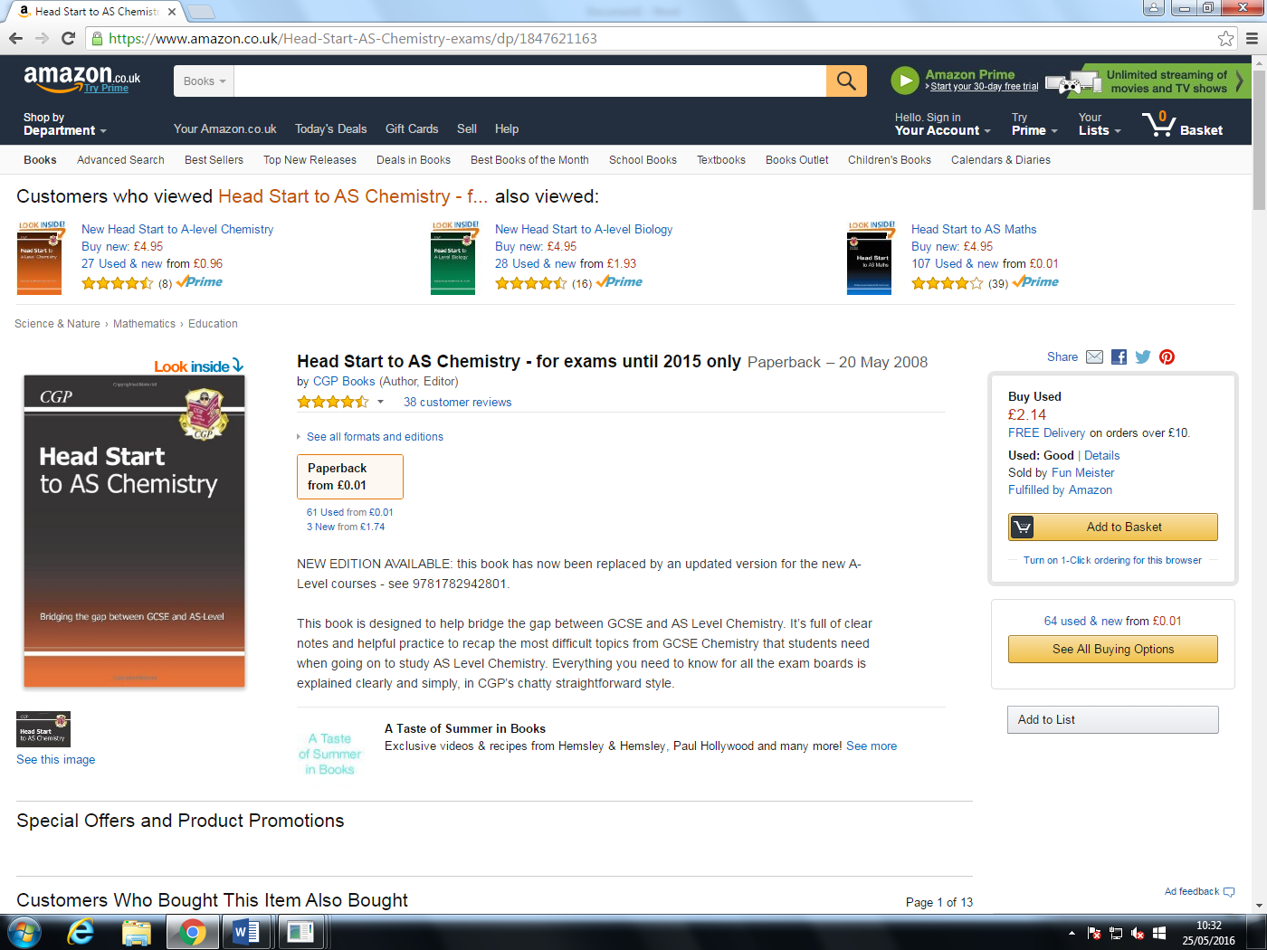

PART 1: FORMULA LITERACY
It is vital as a chemistry student that you know the formulas of common substances. Here is a list of substances whose formulas you should know at all times.
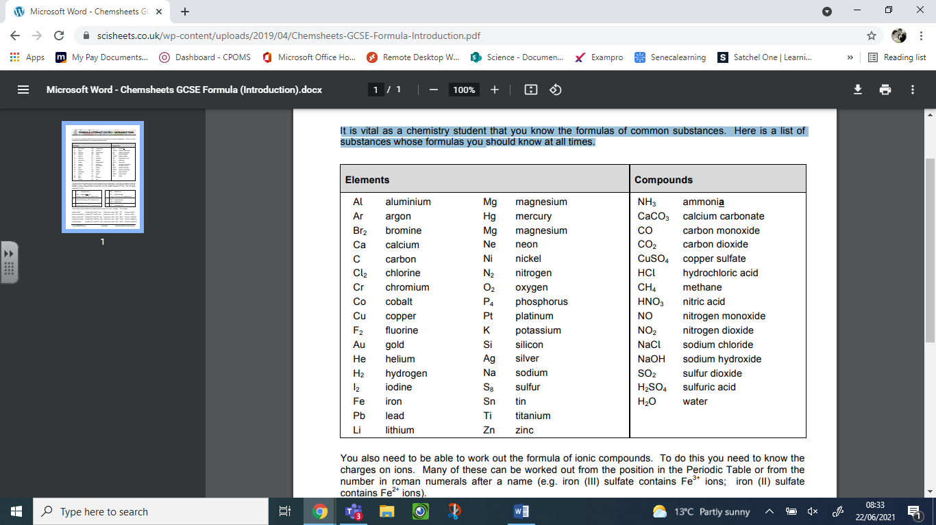
You also need to be able to work out the formula of ionic compounds. To do this you need to know the charges on ions. Many of these can be worked out from the position in the Periodic Table or from the number in roman numerals after a name (e.g. iron (III) sulfate contains Fe3+ ions; iron (II) sulfate contains Fe2+ ions).
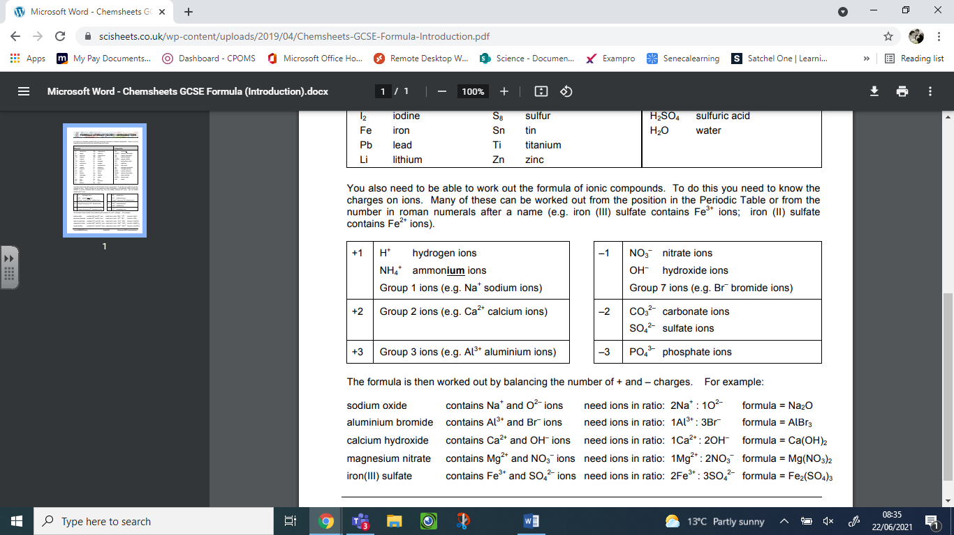

TASK: Work out the formula for the following:
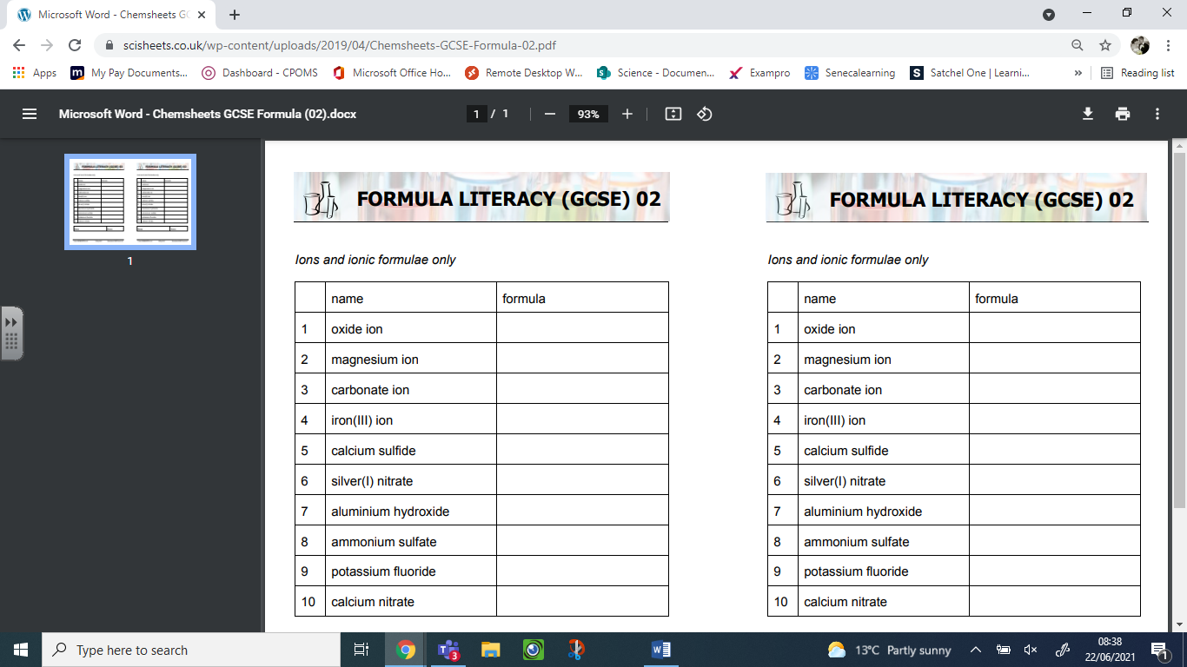

PART 2: BALANCING EQUATIONS
A vital part of chemistry is the ability to balance equations. To do this you will need to be able to work out the theoretical number of moles of each substance and include state symbols. Remember that it is a chemical error (hence no marks awarded) if the wrong state symbols are included. Try practicing the examples on the following page:

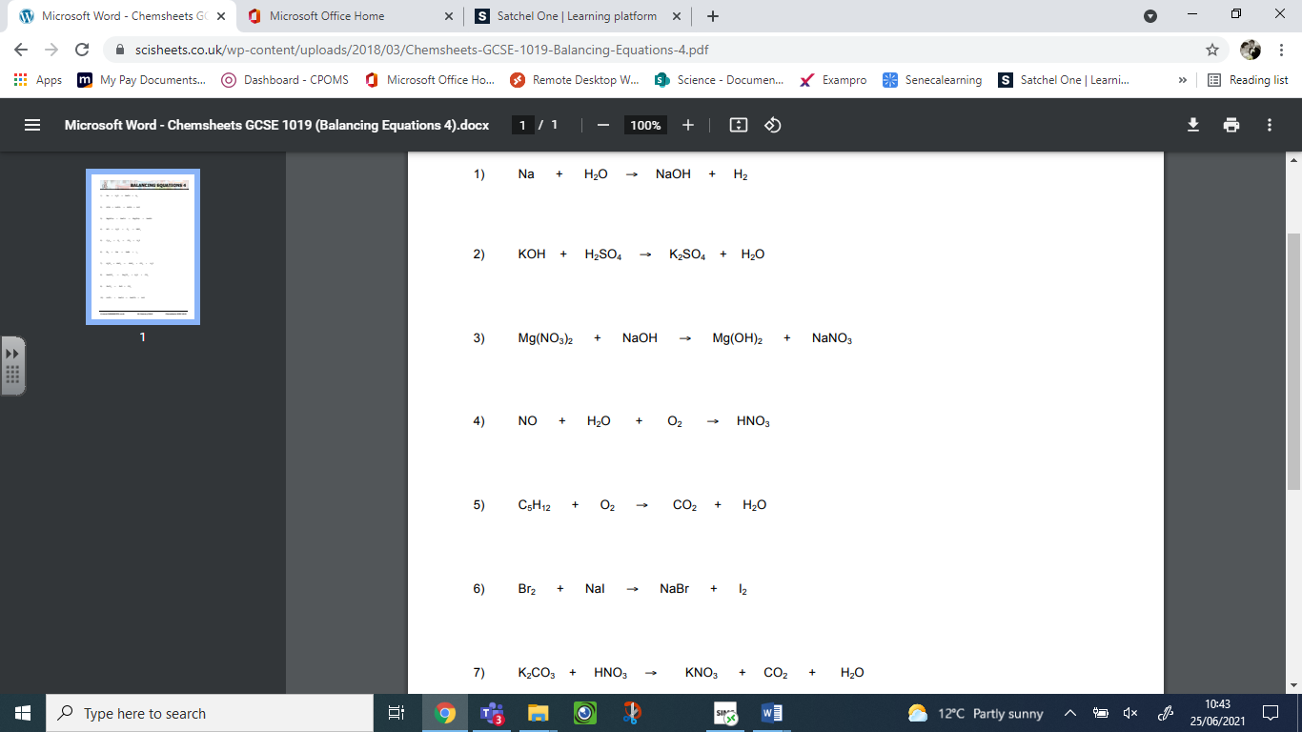

PART 3: MEASURING AMOUNT OF SUBSTANCE

MASS VOLUME MOLAR MASS AVOGADRO
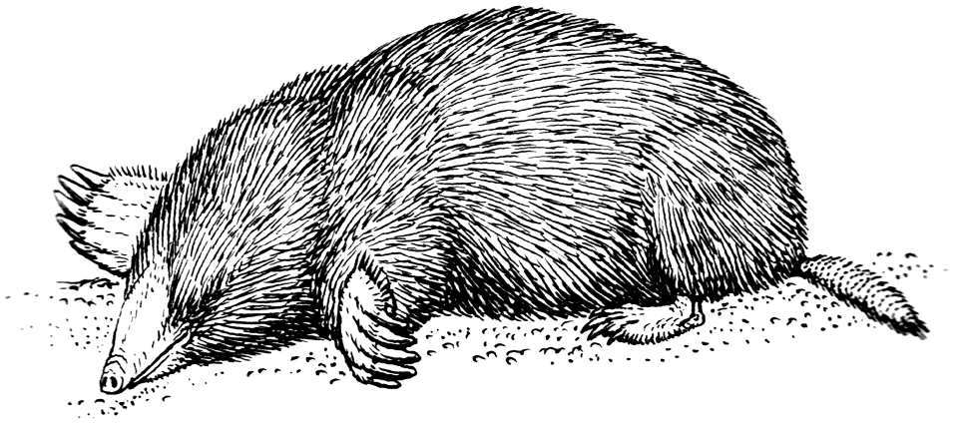
CONCENTRATION ATOM ION MOLECULE

MEASUREMENTS IN CHEMISTRY

Mass
Convert the following into grams:
- 0.25 kg
- 15 kg
- 100 tonnes
- 2 tonnes
Volume
Convert the following into dm³:
- 100 cm³
- 25 cm³
- 50 m³
- 50000 cm³

Tip – always use standard form for very large and very small numbers!
What is a mole?
Atoms and molecules are very small – far too small to count individually!
It is important to know how much of something we have, but we count particles in MOLES because you get simpler numbers
1 mole = 6.02 x 10²³ particles
(6.02 x 10²³ is known as Avogadro’s number)

- If you have 2.5 x 10²¹ atoms of magnesium, how many moles do you have?

- If you have 0.25 moles of carbon dioxide, how many molecules do you have?
How can you work out how many moles you have?

- From a measurement of MASS:
You can find the number of moles of a substance if you are given its mass and you know its molar mass:
number of moles = mass/molar mass
n = m/m_{r}
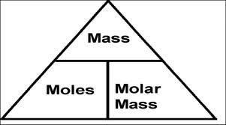
Mass MUST be measured in grams!
Molar mass has units of gmol⁻¹
1. Calculate the number of moles present in: | 2. Calculate the mass of: | 3. Calculate the molar mass of the following substances:
a) 2.3 g of Na | a) 0.05 moles of Cl₂ | a) 0.015 moles, 0.42 g
Ans | Ans | Ans
b) 2.5 g of O₂ | b) 0.125 moles of KBr | b) 0.0125 moles, 0.50 g
Ans | Ans | Ans
c) 240 kg of CO₂ | c) 0.075 moles of Ca(OH)₂ | c) 0.55 moles, 88 g
Ans | Ans | Ans
d) 12.5 g of Al(OH)₃ | d) 250 moles of Fe₂O₃ | d) 2.25 moles, 63 g
Ans | Ans | Ans
e) 5.2 g of PbO₂ | e) 0.02 moles of Al₂(SO₄)₃ | e) 0.00125 moles, 0.312 g
Ans | Ans | Ans

- From a measurement of AQUEOUS VOLUME:
You can find the number of moles of a substance dissolved in water (aqueous) if you are given the volume of solution and you know its molar concentration:
number of moles = aqueous volume x molar concentration
n = V x C
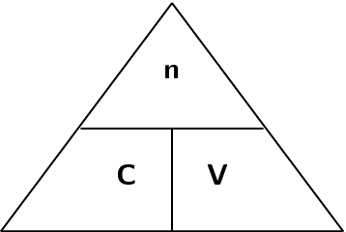
Aqueous volume MUST be measured in dm³!
concentration has units of moldm⁻³
If you know the molar mass of the substance, you can convert the molar concentration into a mass concentration:
Molar concentration (moldm⁻³) x m_{r} = mass concentration (gdm⁻³)
1. Calculate the number of moles of substance present in each of the following solutions: | 2. Calculate the molar concentration and the mass concentration of the following solutions: | 3. Calculate the molar concentration and the mass concentration of the following solutions:
a) 25 cm³ of 0.1 moldm⁻³ HCl | a) 0.05 moles of HCl in 20 cm³ | a) 35 g of NaCl in 100 cm³
Ans | Ans | Ans
b) 40 cm³ of 0.2 moldm⁻³ HNO₃ | b) 0.01 moles of NaOH in 25 cm³ | b) 20 g of CuSO₄ in 200 cm³
Ans | Ans | Ans
c) 10 cm³ of 1.5 moldm⁻³ NaCl | c) 0.002 moles of H₂SO₄ in 16.5 cm³ | c) 5 g of HCl in 50 cm³
Ans | Ans | Ans
d) 5 cm³ of 0.5 moldm⁻³ AgNO₃ | d) 0.02 moles of CuSO₄ in 200 cm³ | d) 8 g of NaOH in 250 cm³
Ans | Ans | Ans
e) 50 cm³ of 0.1 moldm⁻³ H₂SO₄ | e) 0.1 moles of NH₃ in 50 cm³ | e) 2.5 g of NH₃ in 50 cm³
Ans | Ans | Ans

- From a measurement of GASEOUS VOLUME:
You can find the number of moles of a gas if you are given the volume of the gas:
number of moles = volume / 24
n = V / 24
24 dm³ is the volume occupied by 1 mole of any gas at room temperature and pressure
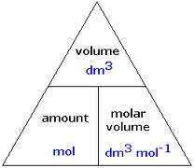
Volume MUST be measured in dm³!

1. Calculate the number of moles present in: |  | 2. Calculate the volume of gas occupied by: | 3. Calculate the mass of the following gas samples:
a) 48 dm³ of O₂ |  | a) 0.05 moles of Cl₂ | a) 48 dm³ of O₂
Ans | Ans |  |  | Ans
b) 1.2 dm³ of CO₂ |  | b) 0.25 moles of CO₂ | b) 1.2 dm³ of CO₂
Ans |  | Ans | Ans
c) 200 cm³ of N₂ |  | c) 28 g of N₂ | c) 200 cm³ of N₂
Ans |  | Ans | Ans
d) 100 dm³ of Cl₂ |  | d) 3.2 g of O₂ | d) 100 dm³ of Cl₂
Ans |  | Ans | Ans
e) 60 cm³ of NO₂ |  | e) 20 g of NO₂ | e) 60 cm³ of NO₂
Ans |  | Ans | Ans

How can we use chemical equations to work out the actual number of moles of a substance?
Chemical Equations show the ratio in which different species react in a chemical equation.
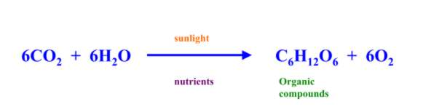
This equation shows that 6 moles carbon dioxide of react with 6 mole of water to make 1 mole of glucose and 6 moles of oxygen.
6: 6: 1: 6
- How many moles of water are needed to react with 0.03 moles of carbon dioxide?
- How many moles of glucose can you make from 0.03 moles of carbon dioxide?
- How many moles of oxygen can you make from 0.03 moles of carbon dioxide?

Equation 1: Mg + 2 HCl → MgCl₂ + H₂
a) How many moles of magnesium would be needed to react with 0.01 moles of hydrochloric acid?
b) How many moles of hydrogen could be produced from 0.01 moles of hydrochloric acid?
Equation 2: 2 H₂S + 3 O₂ → 2 SO₂ + 2 H₂O
a) How many moles of oxygen is needed to react with 0.5 moles of hydrogen sulphide?
b) How many moles of sulphur dioxide can be made from 0.5 moles of hydrogen sulphide?

Equation 3: 4 K + O₂ → 2 K₂O
a) How many moles of oxygen are needed to react with 0.05 moles of potassium?
b) How many moles of potassium oxide can be made from 0.05 moles of potassium?

Calculating Reacting Quantities from Chemical Equations
You perform these calculations in three steps:
- calculate the number of moles of one of the substances (you will either be given the mass, or the aqueous volume and the concentration, or the gaseous volume)
- use the equation to work out the number of moles of the other substance
- use one of the mole relationships to work out the quantity you need

1) What mass of hydrogen is produced when 192 g of magnesium is reacted with hydrochloric acid?
Mg + 2 HCl → MgCl₂ + H₂ (3)

2) What mass of oxygen is needed to react with 8.5 g of hydrogen sulphide (H₂S)?
2 H₂S + 3 O₂ 2 SO₂ + 2 H₂O (3)

3) What mass of potassium oxide is formed when 7.8 g of potassium is burned in oxygen?
4 K + O₂ 2 K₂O (3)

4) What mass of oxygen is required to oxidise 10 g of ammonia to NO?
4 NH₃ + 5 O₂ → 4 NO + 6 H₂O (3)

5) What mass of aluminium oxide is produced when 135 g of aluminium is burned in oxygen?
2 Al + 3 O₂ Al₂O₃ (3)

6) What mass of iodine is produced when 7.1 g of chlorine reacts with excess potassium iodide?
Cl₂ + 2 KI 2 KCl + I₂ (3)

7) What volume of hydrogen is needed to react with 32 g of copper oxide?
CuO + H₂ → Cu + H₂O (3)

8) What volume of oxygen is formed when 735 g of potassium chlorate decomposes?
2 KClO₃ → 2 KCl + 3 O₂ (3)

9) What volume of hydrogen is produced when 195 g of potassium is added to water?
2 K + 2 H₂O 2 KOH + H₂ (3)

10) What mass of calcium carbonate is required to produce 1.2 dm³ of carbon dioxide?
CaCO₃ CaO + CO₂ (3)

PART 4: BRIDGING THE GAP BETWEEN GCSE AND A LEVEL ORGANIC CHEMISTRY

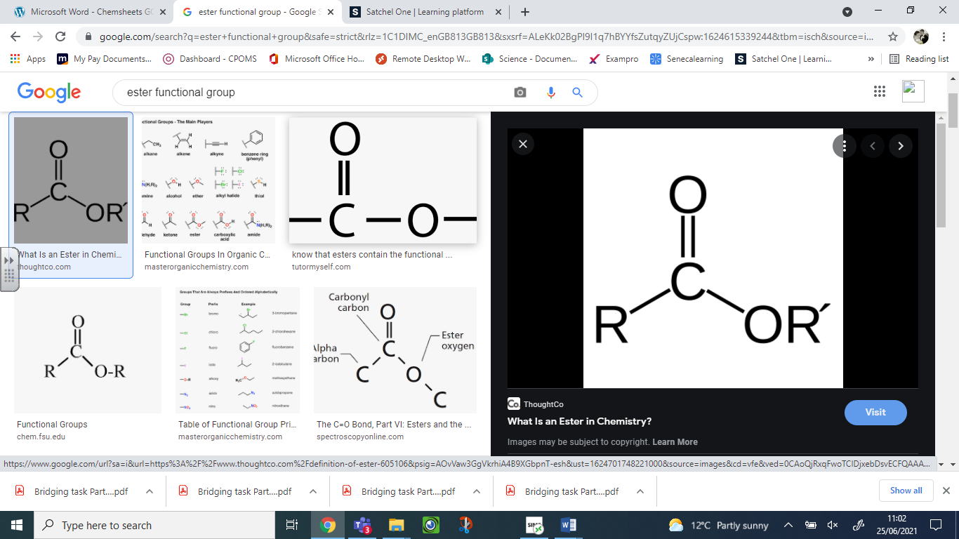Organic chemistry contributes approx. 25% towards the A level chemistry course. It is vital that you ensure you are able to name and draw organic compounds starting with alkanes and alkenes, also, compounds containing the following functional groups; alcohols (-OH), carboxylic acids (-COOH) and esters .

Part 4a: Alkanes
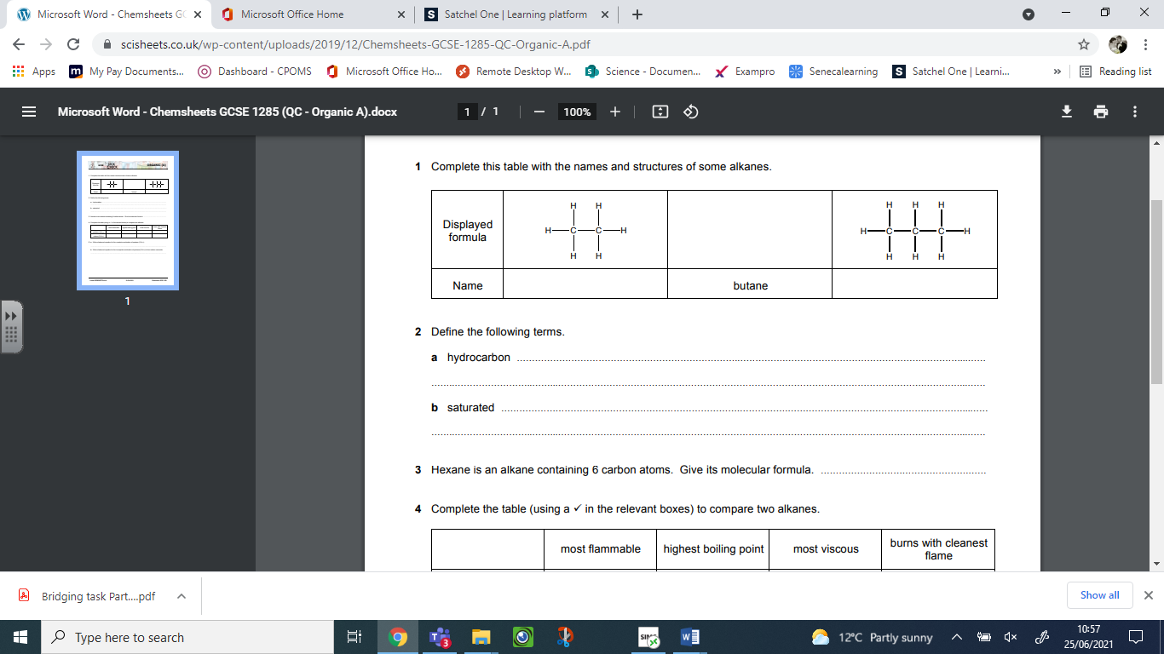
Part 4b: Alkenes
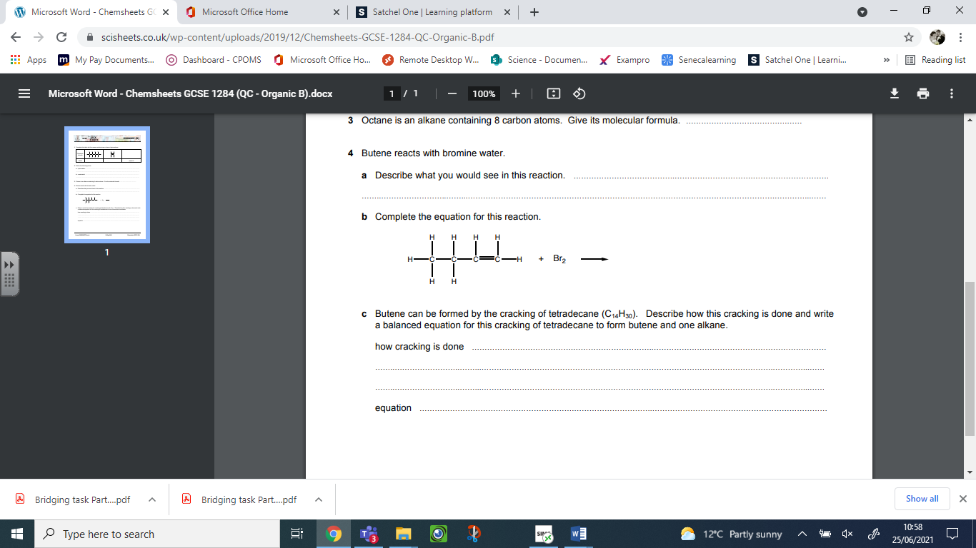

Part 4c: Naming and identifying key functional groups
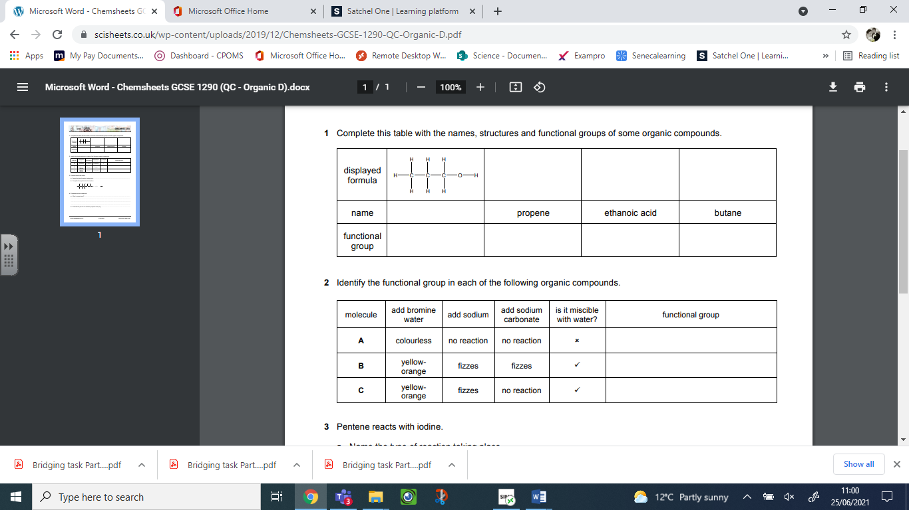
Part 4d: Esters and naming functional groups
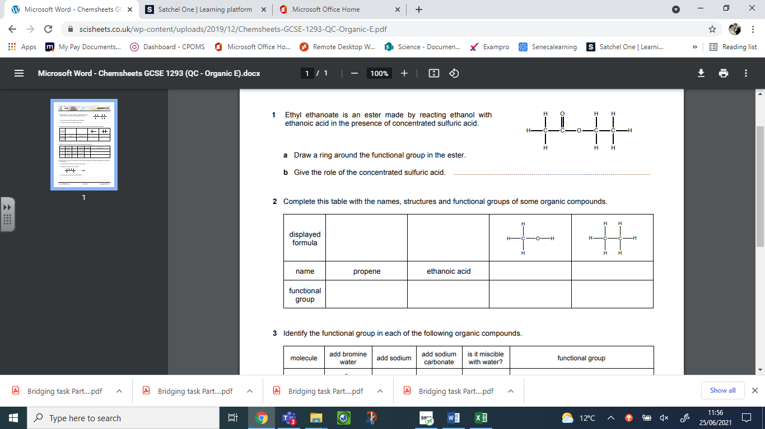
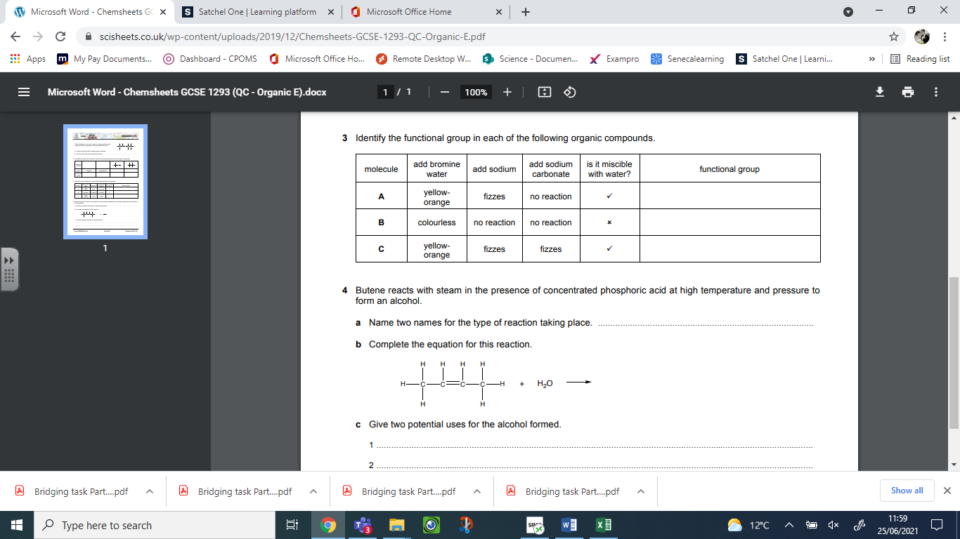
Part 4e: Addition and condensation polymers
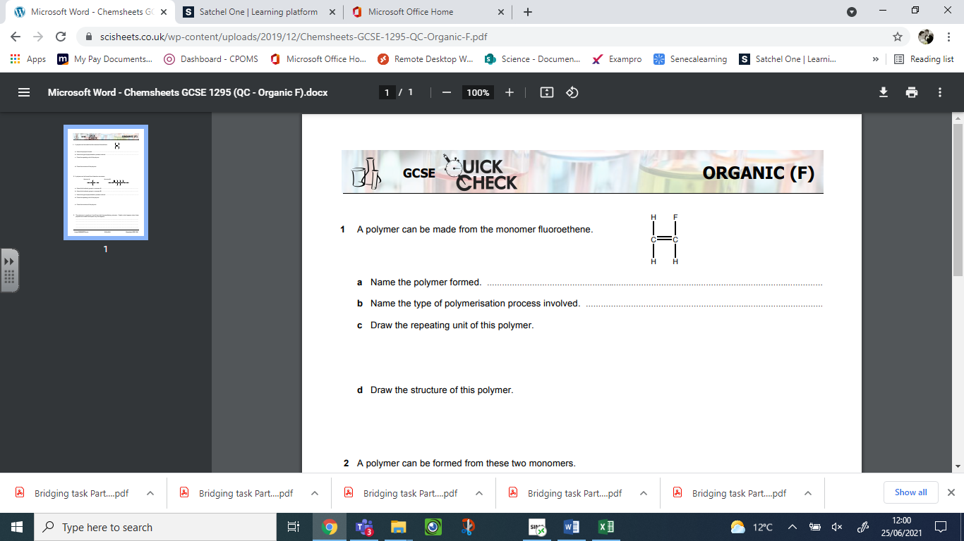
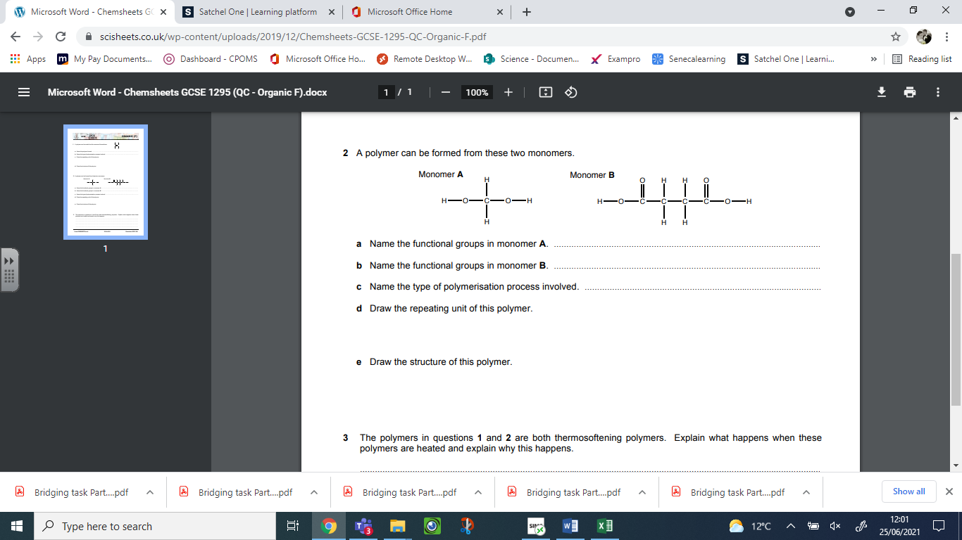
Part 5 - Practical work for the A level Chemist

Complete the table below:
Key word | Definition
Accuracy
Precision
Repeatability
Reproducibility
Anomalous result
Independent variable
Dependent variable
Control variable
Range
Interval
Validity
Reliability
Resolution
Uncertainty
Zero error
Systematic error
Random error

Using your definitions, read through the investigation and complete the practical skills questions:
Reaction of Metals with Acid (Rate of Reaction)
Experiment:
Investigate the rate of reaction of magnesium with hydrochloric acid by measuring the volume of hydrogen gas produced over time.
Practical Skills Questions:
- What is the dependent variable in this experiment?

- Name two control variables you should keep constant.

- What does it mean for your measurements of gas volume to be accurate?

- Why should you repeat the experiment?

- How would you deal with an anomalous result?

Energy Changes in Chemical Reactions (Temperature Change)
Experiment:
Investigate the temperature change when mixing hydrochloric acid and sodium hydroxide.
Practical Skills Questions:
- What is the dependent variable?

- What is meant by resolution of the thermometer?

- How would you improve the precision of your results?

- What is the benefit of calculating the mean temperature change?

- What does validity mean in this experiment?

Neutralisation Titration
Experiment:
Determine the concentration of an unknown acid by titration with sodium hydroxide and a suitable indicator.
Practical Skills Questions:
- What does accuracy mean in this experiment?

- Why should you use a burette rather than a measuring cylinder?

- Why is repeatability important in a titration?

- How would you identify a systematic error?

- What is meant by an uncertainty in a burette reading?

Task 3: Application in Chemistry:
Part 1 – Analysis questions
1) When a halogen is added to a solution containing halide ions, a displacement reaction may occur. The table shows whether a reaction occurs.
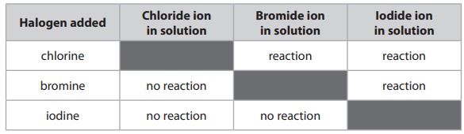
Using information from the table, explain the order of reactivity of the three halogens. (3)


2) The diagram represents the structure of pure aluminium, and the structure of an alloy of aluminium.
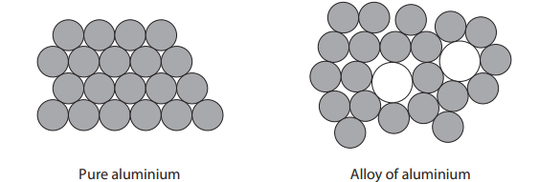
Pure aluminium Alloy of aluminium Use the diagram to explain why the alloy is harder than pure aluminium. (3)
3) A student investigates the reaction between sodium hydroxide solution and dilute hydrochloric acid. The graph shows the student’s results.
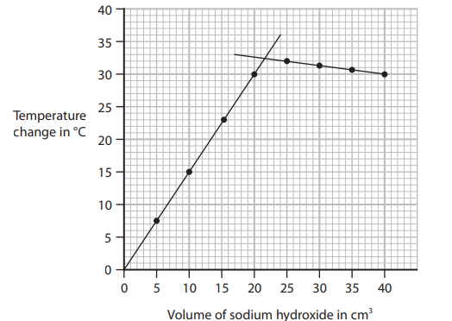

(ai) Use the graph to determine the maximum temperature change in °C. (1)

maximum temperature change = .............................................................. °C

(ii) Explain the shape of the graph. (3)
(b) The student repeats the experiment using a polystyrene cup.
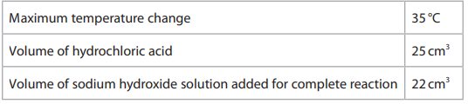
Calculate the heat energy change (Q) in kJ. [for the solution, 1.0 cm³ has a mass of 1.0g c = 4.2J/g/°C] (4)

Q = .............................................................. kJ

Part 2 - Extended response questions
1) A technician needs to identify the solution in an unlabelled bottle. The technician knows that the solution contains one of these compounds. • iron(II) bromide • iron(II) chloride • iron(III) bromide • iron(III) chloride Describe how the technician can use chemical tests to identify the compound. (6 marks)

Write answer on the space on the next page…

2) In an experiment, 20cm³ of hydrochloric acid containing 0.0036mol were reacted with 1.3g of zinc granules at a temperature of 30°C and curve A was obtained. The student does two more experiments and obtains curves B and C.
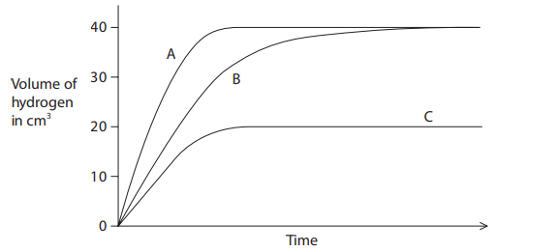
(i) In one of these experiments the student repeats the original method but at a temperature of 20°C. Explain in terms of particle collision theory why the curve obtained could be curve B. (4)
3) Ethane (C₂H₆) and ethene (C₂H₄) both react with bromine.
Describe the differences in the reactions of ethane and ethene with bromine. Refer to the conditions, the products and the types of reaction involved. (5)
2) (optional)In preparation for your first lesson in September, you need to complete an A3 poster on one of the following topics:
- How can chemistry help us deal with environmental issues such as CO2 build-up and the greenhouse effect; automobile emission control; acid rain; eutrophication of lakes; lead, mercury?
- In the past we have used chemicals that we thought were safe that have turned out to cause harm, such as lead. How can we be sure that we are not repeating our mistakes?
- How is the Periodic Table important for all of science and not just chemistry?
- Are two atoms of the same element identical?
- What are the differences between physical and chemical reactions in chemistry?

